***HTML DOM***

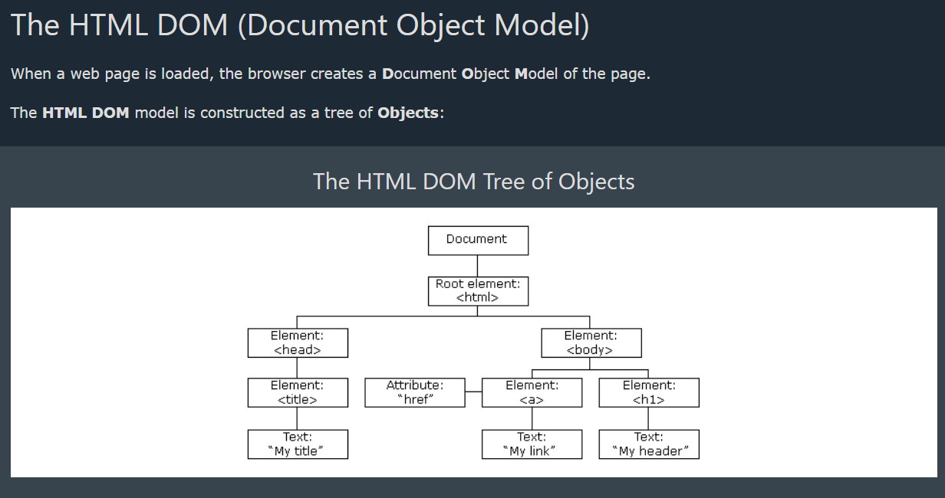

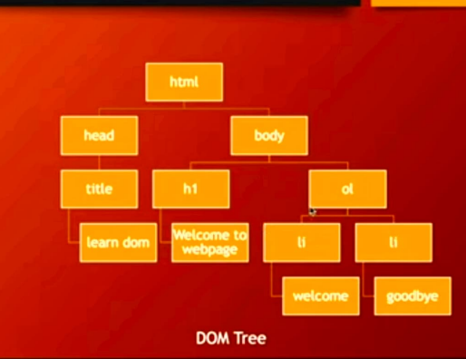

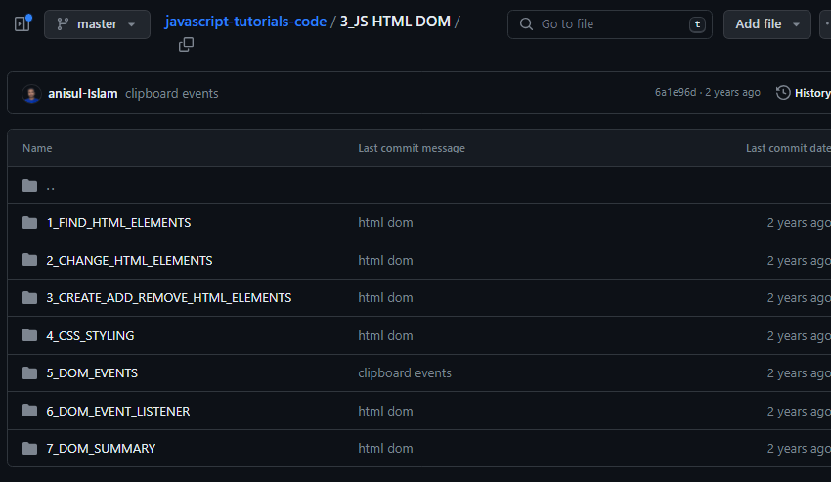

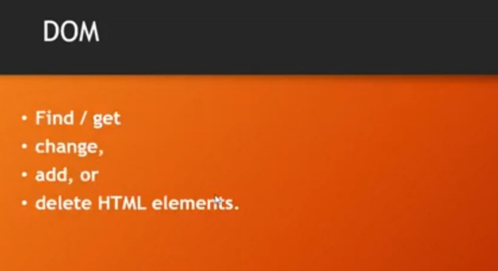

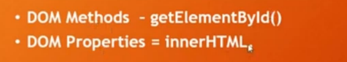

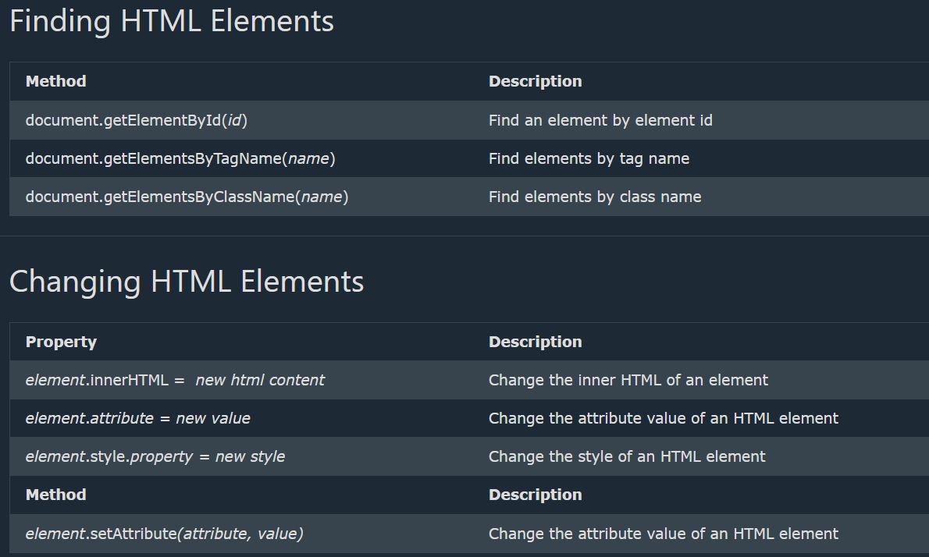

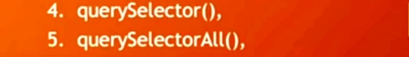



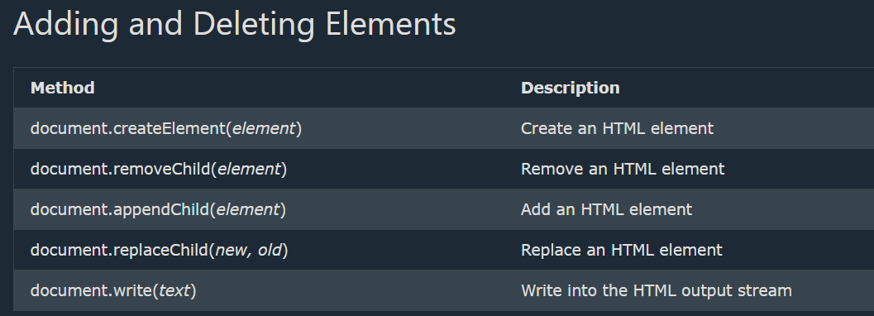

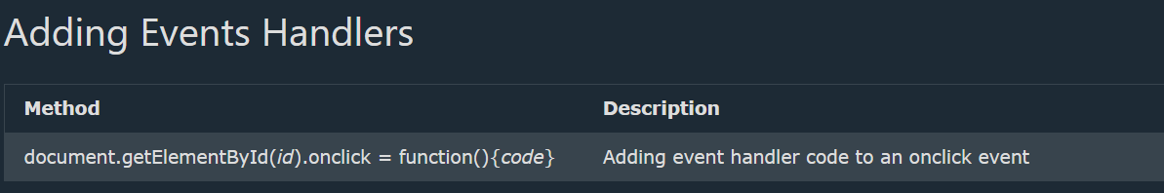

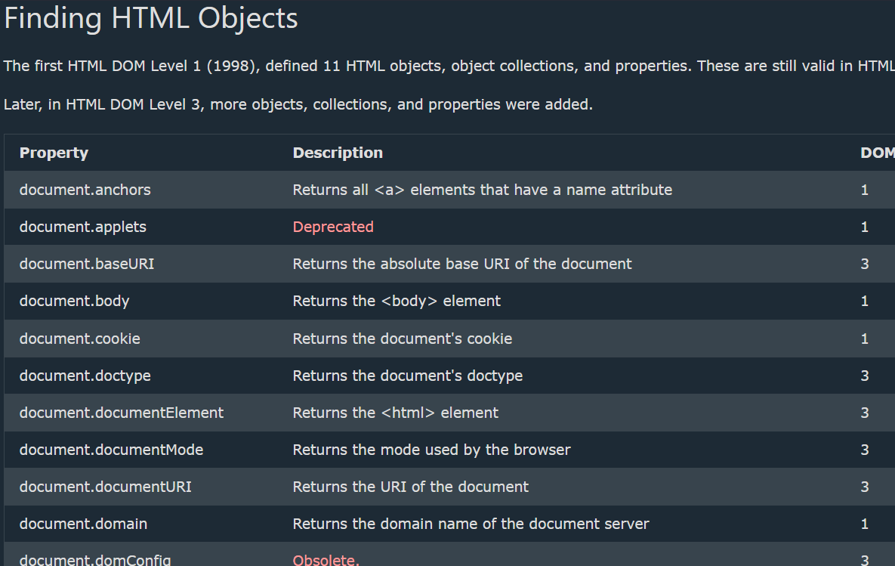

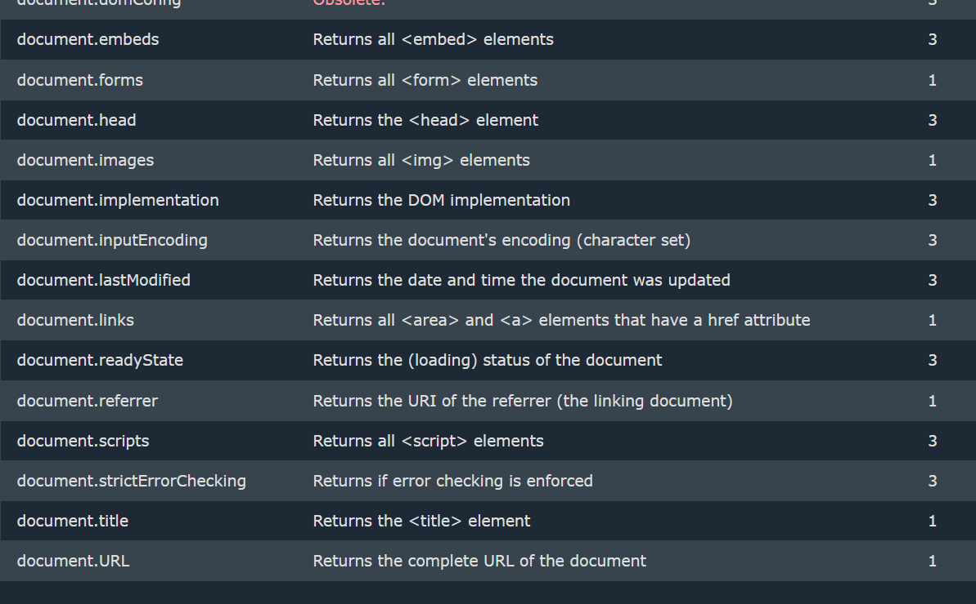

***Finding HTML Elements***

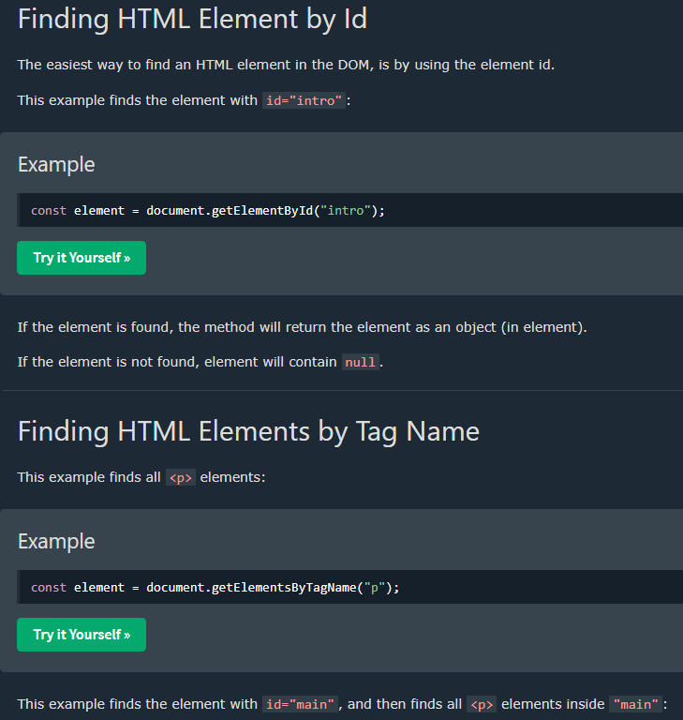

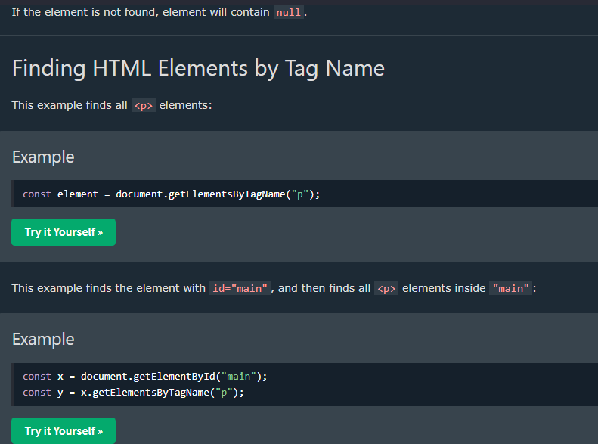

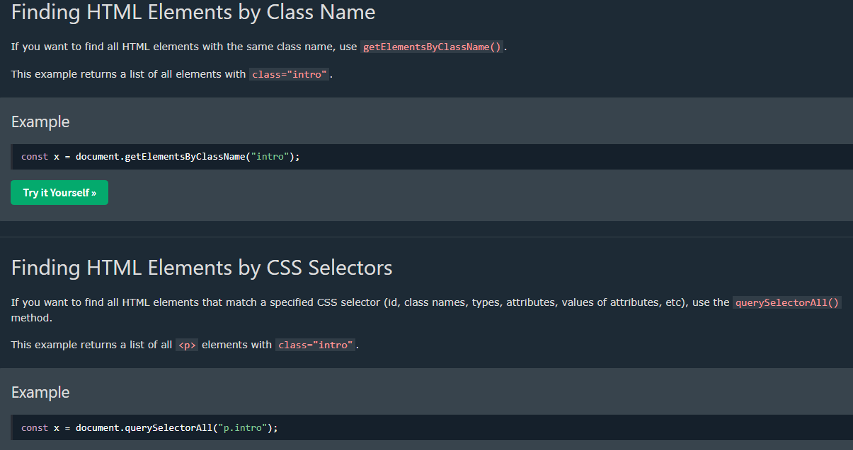

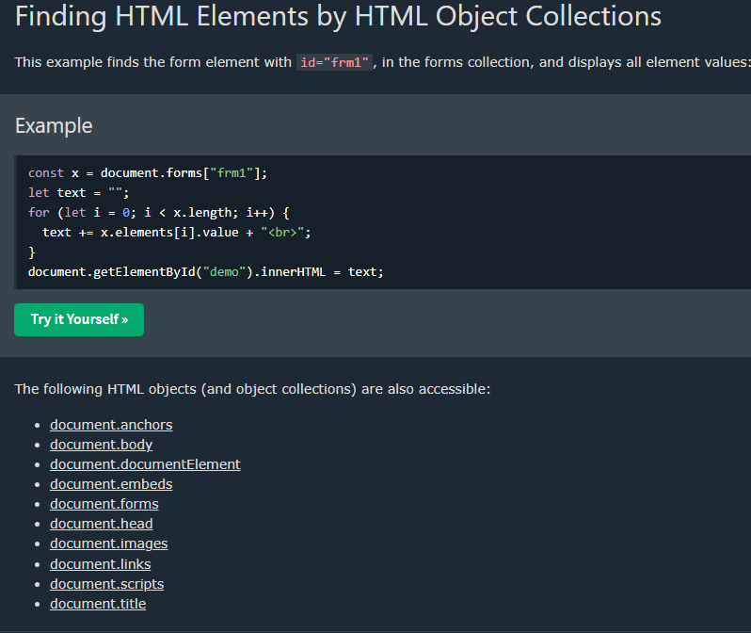

[1_FIND_HTML_ELEMENTS](https://github.com/anisul-Islam/javascript-tutorials-code/tree/master/3_JS%20HTML%20DOM/1_FIND_HTML_ELEMENTS)

**index.html**

<!DOCTYPE html>

<html lang="en">

<head>

<meta charset="UTF-8">

<meta name="viewport" content="width=device-width, initial-scale=1.0">

<title>Document</title>

</head>

<body>

<h1>This is h1</h1>

<h2 id="heading2">This is h2</h2>

<p class="para">This is a paragraph1</p>

<p class="para">This is a paragraph2</p>

<a href="#">Visit Google</a>

<div id="first-div">

<h4>I am h4</h4>

</div>

<div class="my-div">

<ol>

<li>I am a list</li>

</ol>

</div>

<script src="./program27.js"></script>

</body>

</html>

**program27.js**

// DOM -> Document Object Model

// Using DOM We can Find / get, change, add, or delete HTML elements.

// How to find HTML Elements

// document.getElementById()

// document.getElementsByTagName()

// document.getElementsByClassName()

// document.querySelector()

// finding element by ID

var h2 = document.getElementById("heading2");

console.log(h2)

// finding element by tagName

var h1 = document.getElementsByTagName("h1")[0];

console.log(h1)

// finding element by tagName

var p = document.getElementsByClassName("para")[0];

console.log(p)

// finding element by querySelector

var q1 = document.querySelector("#heading2");

console.log(q1)

//it will get the first element of the h1 elements

var q2 = document.querySelector("h1");

console.log(q2)

//it will get the first element of the para class

var q3 = document.querySelector(".para");

console.log(q3)

var list = document.querySelector(".my-div li");

console.log(list)

// finding element by querySelectorAll

var q4 = document.querySelectorAll(".para");

console.log(q4)

***Changing HTML Content***

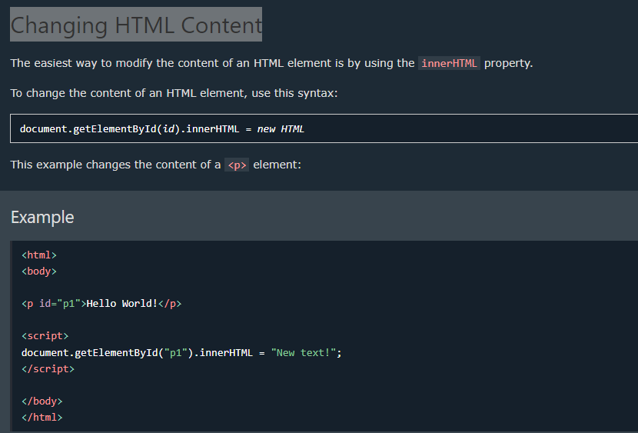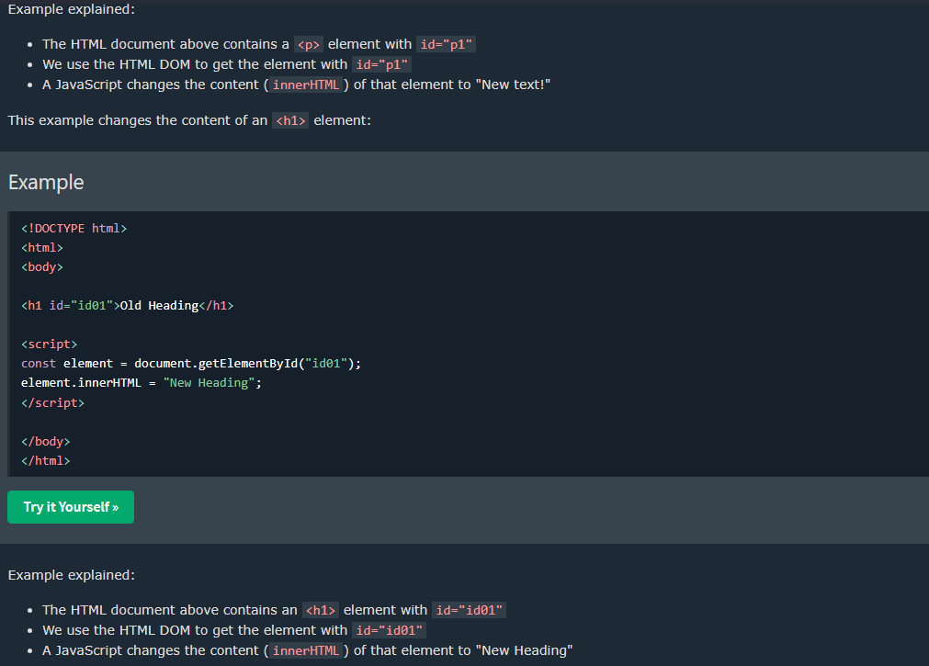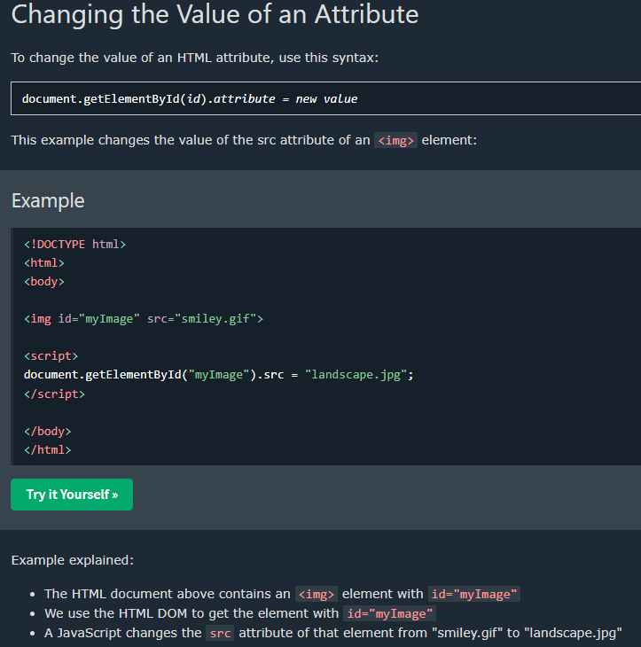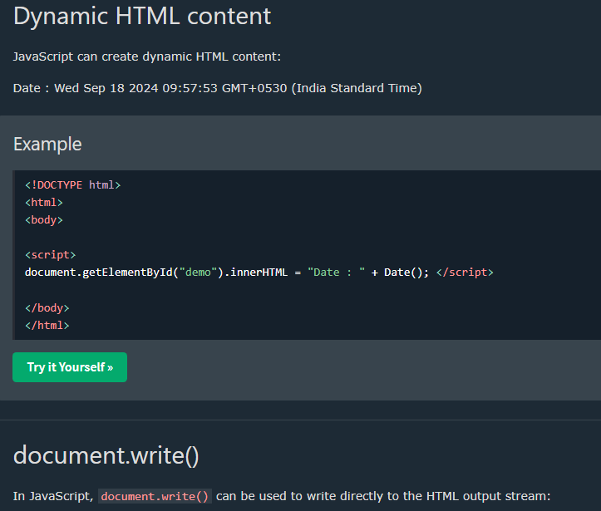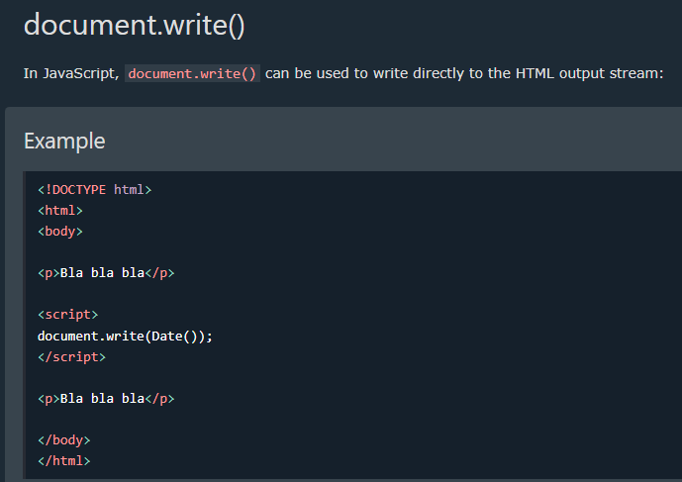**Never use document.write() after the document is loaded. It will overwrite the document.

[2_CHANGE_HTML_ELEMENTS](https://github.com/anisul-Islam/javascript-tutorials-code/tree/master/3_JS%20HTML%20DOM/2_CHANGE_HTML_ELEMENTS)

**index.htm**

<!DOCTYPE html>

<html lang="en">

<head>

<meta charset="UTF-8">

<meta name="viewport" content="width=device-width, initial-scale=1.0">

<title>change html elements</title>

</head>

<body>

<h1>This is h1</h1>

<h2 id="heading2">This is h2</h2>

<p class="para">This is a paragraph1</p>

<p class="para">This is a paragraph2</p>

<a href="#">Visit Google</a>

<div id="first-div">

<h4>I am h4</h4>

</div>

<div class="my-div">

<ol>

<li>I am a list</li>

</ol>

</div>

<script src="./program28.js"></script>

</body>

</html>

**program28.js**

// How to change HTML Elements (collected from W3School website)

// element.innerHTML = new html content -> Change the inner HTML of an element

// element.attribute = new value -> Change the attribute value of an HTML element

// element.style.property = new style -> Change the style of an HTML element

// finding element by ID

var h2 = document.getElementById("heading2");

// changing elements text, id

h2.innerHTML = "I love Bangladesh";

h2.id = "heading2-new";

console.log(h2);

var a = document.querySelector("a");

console.log(a)

a.textContent="visit my website";

a.href="http://www.studywithanis.com"

// changing style of element

a.style.textDecoration = "none";

a.style.color = "green";

a.style.fontSize = "2rem";

[3_CREATE_ADD_REMOVE_HTML_ELEMENTS](https://github.com/anisul-Islam/javascript-tutorials-code/tree/master/3_JS%20HTML%20DOM/3_CREATE_ADD_REMOVE_HTML_ELEMENTS)

**index.html**

<!DOCTYPE html>

<html lang="en">

<head>

<meta charset="UTF-8">

<meta name="viewport" content="width=device-width, initial-scale=1.0">

<title>Document</title>

</head>

<body>

<h1>This is h1</h1>

<h2 id="heading2">This is h2</h2>

<p class="para">This is a paragraph1</p>

<p class="para">This is a paragraph2</p>

<a href="#">Visit Google</a>

<div id="first-div">

<h4>I am h4</h4>

</div>

<div class="my-div">

<ol>

<li>I am a list</li>

</ol>

</div>

<script src="./index.js"></script>

</body>

</html>

**index.js**

//Create, remove, add html element

// creating html element and adding to a div

var firstDiv = document.querySelector("#first-div");

console.log(firstDiv)

var heading3 = document.createElement("h3");

var text = document.createTextNode("This is heading 3");

heading3.appendChild(text);

firstDiv.appendChild(heading3);

var heading5 = document.createElement("h5");

var text = document.createTextNode("This is heading 5");

heading5.appendChild(text);

firstDiv.appendChild(heading5);

// remove element

firstDiv.removeChild(heading5);

//adding element before

var heading6 = document.createElement("h6");

var text = document.createTextNode("This is heading 6");

heading6.appendChild(text);

firstDiv.insertBefore(heading6, heading3);

// firstDiv.insertAfter(heading6, heading3);

[4_CSS_STYLING](https://github.com/anisul-Islam/javascript-tutorials-code/tree/master/3_JS%20HTML%20DOM/4_CSS_STYLING)

**style.css**

.heading-style{

color: green;

font-size: 3rem;

font-weight: bold;

font-style: italic;

}

**index.html**

<!DOCTYPE html>

<html lang="en">

<head>

<meta charset="UTF-8">

<meta name="viewport" content="width=device-width, initial-scale=1.0">

<title>Document</title>

<link rel="stylesheet" href="./style.css">

</head>

<body>

<h1>This is h1</h1>

<h2 id="heading2">This is h2</h2>

<p class="para">This is a paragraph1</p>

<p class="para">This is a paragraph2</p>

<a href="#">Visit Google</a>

<div id="first-div">

<h4>I am h4</h4>

</div>

<div class="my-div">

<ol>

<li>I am a list</li>

</ol>

</div>

<script src="./index.js"></script>

</body>

</html>

**index.js**

// Adding & removing css style in js

var h1 = document.querySelector("h1");

h1.innerHTML = "hiiii"

console.log(h1)

//add css style

h1.classList.add('heading-style')

//removing css style

// h1.classList.remove('heading-style')

*DOM Event*

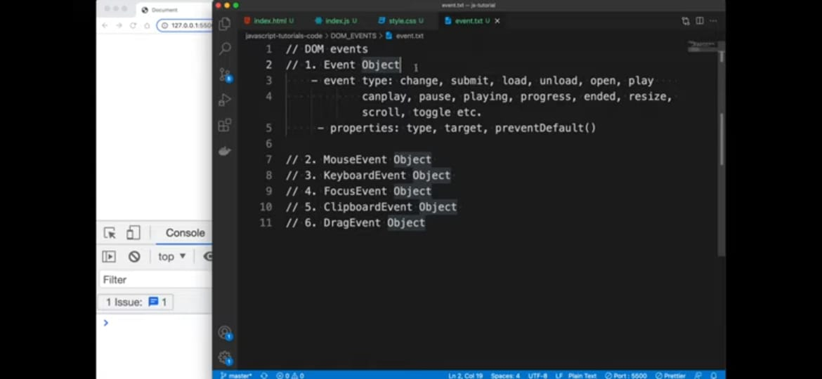

*Click Event*

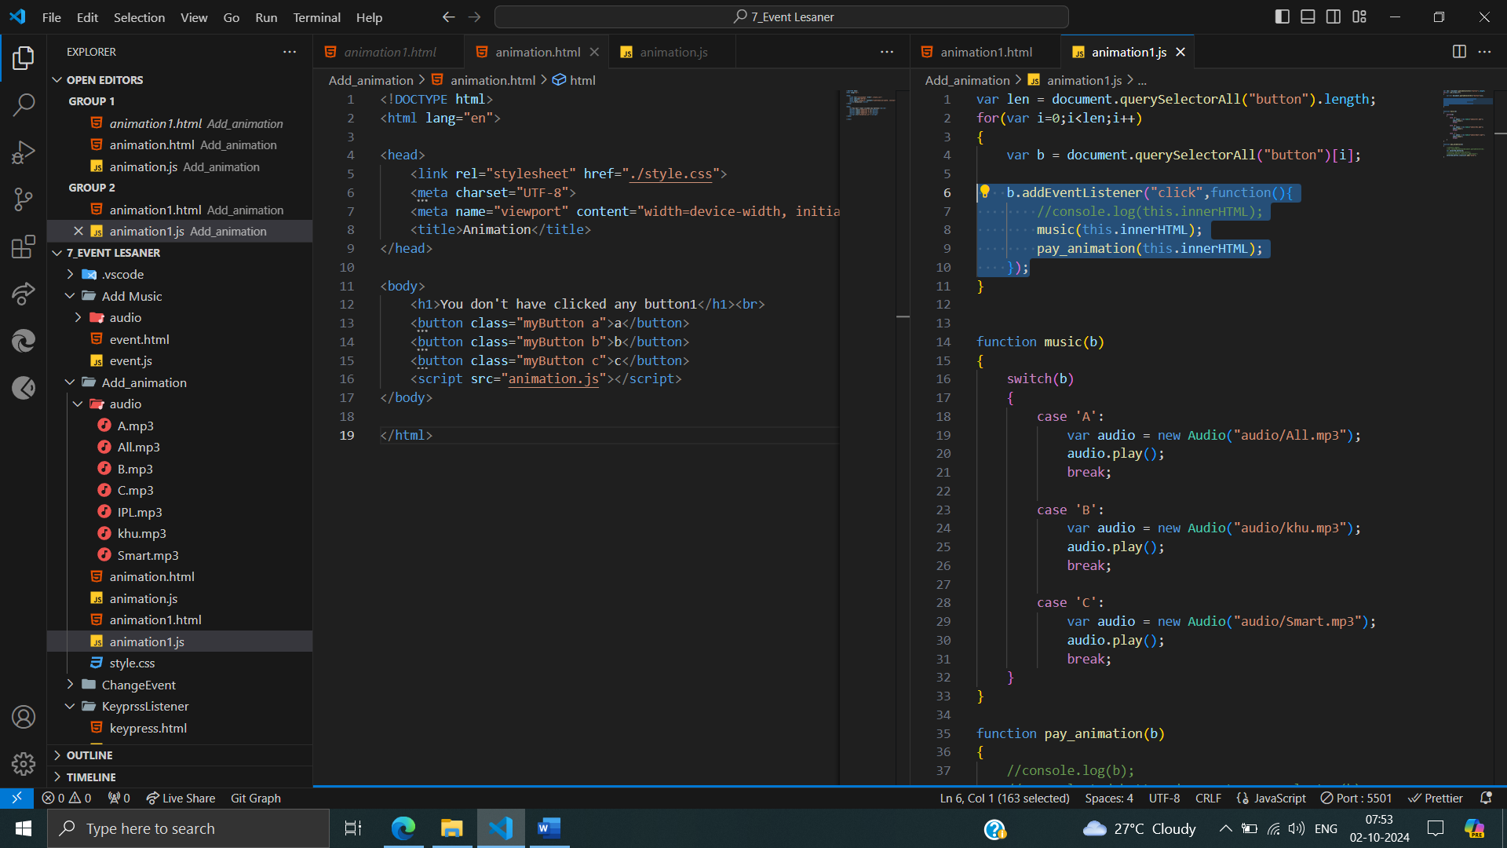

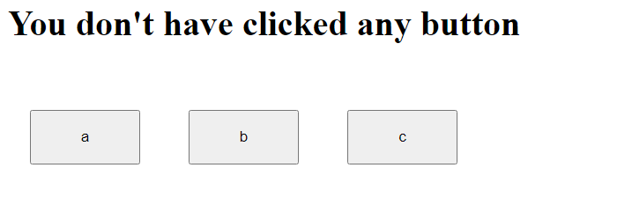

After called click event:

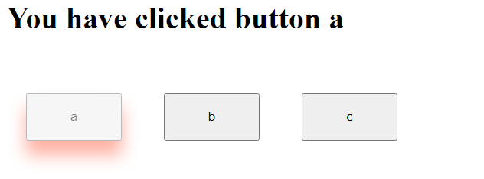

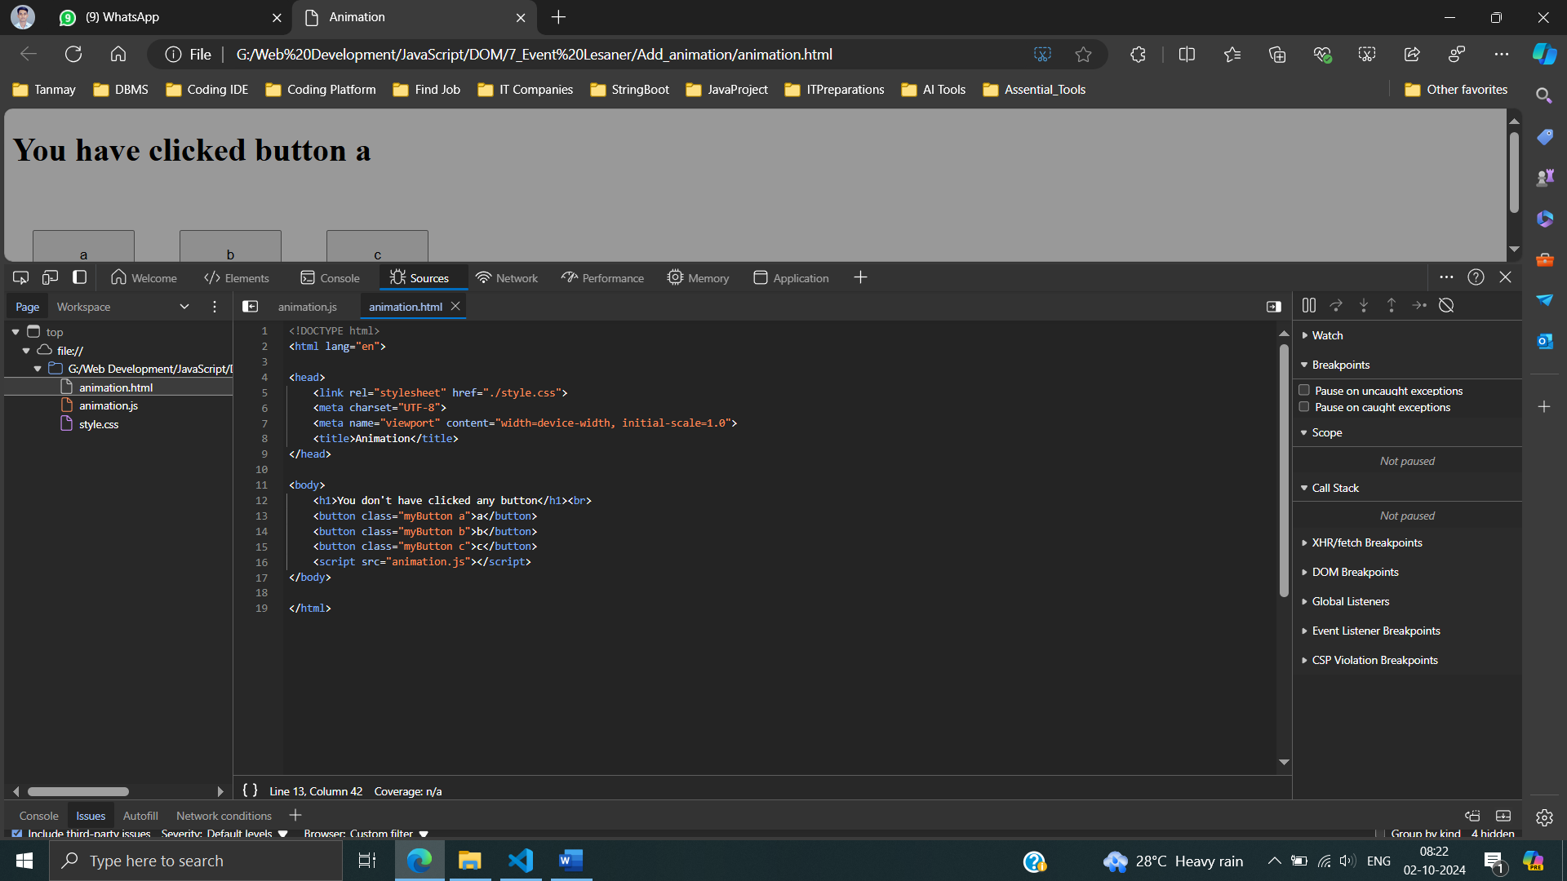

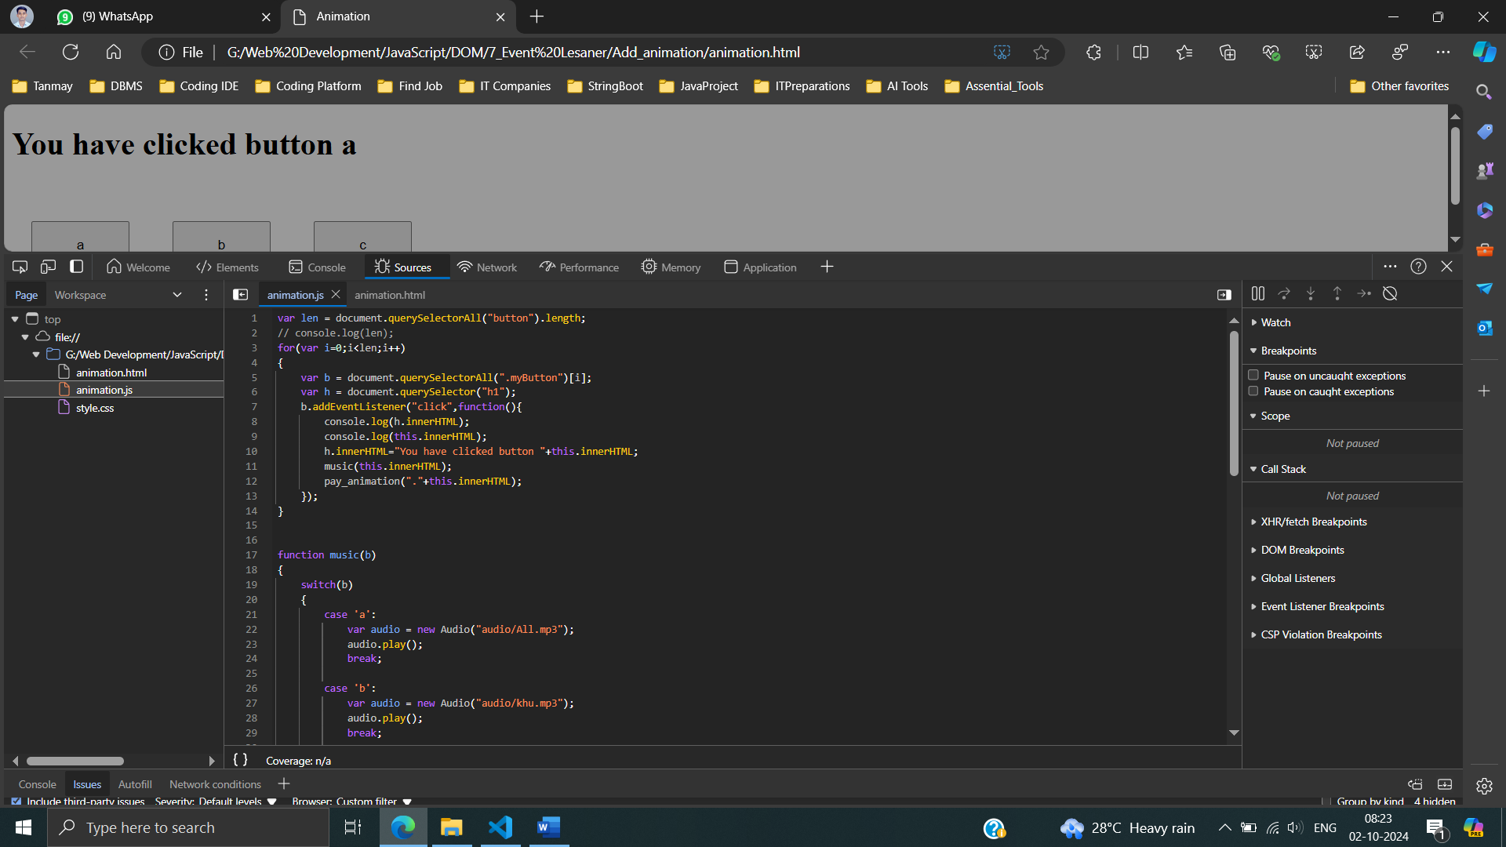 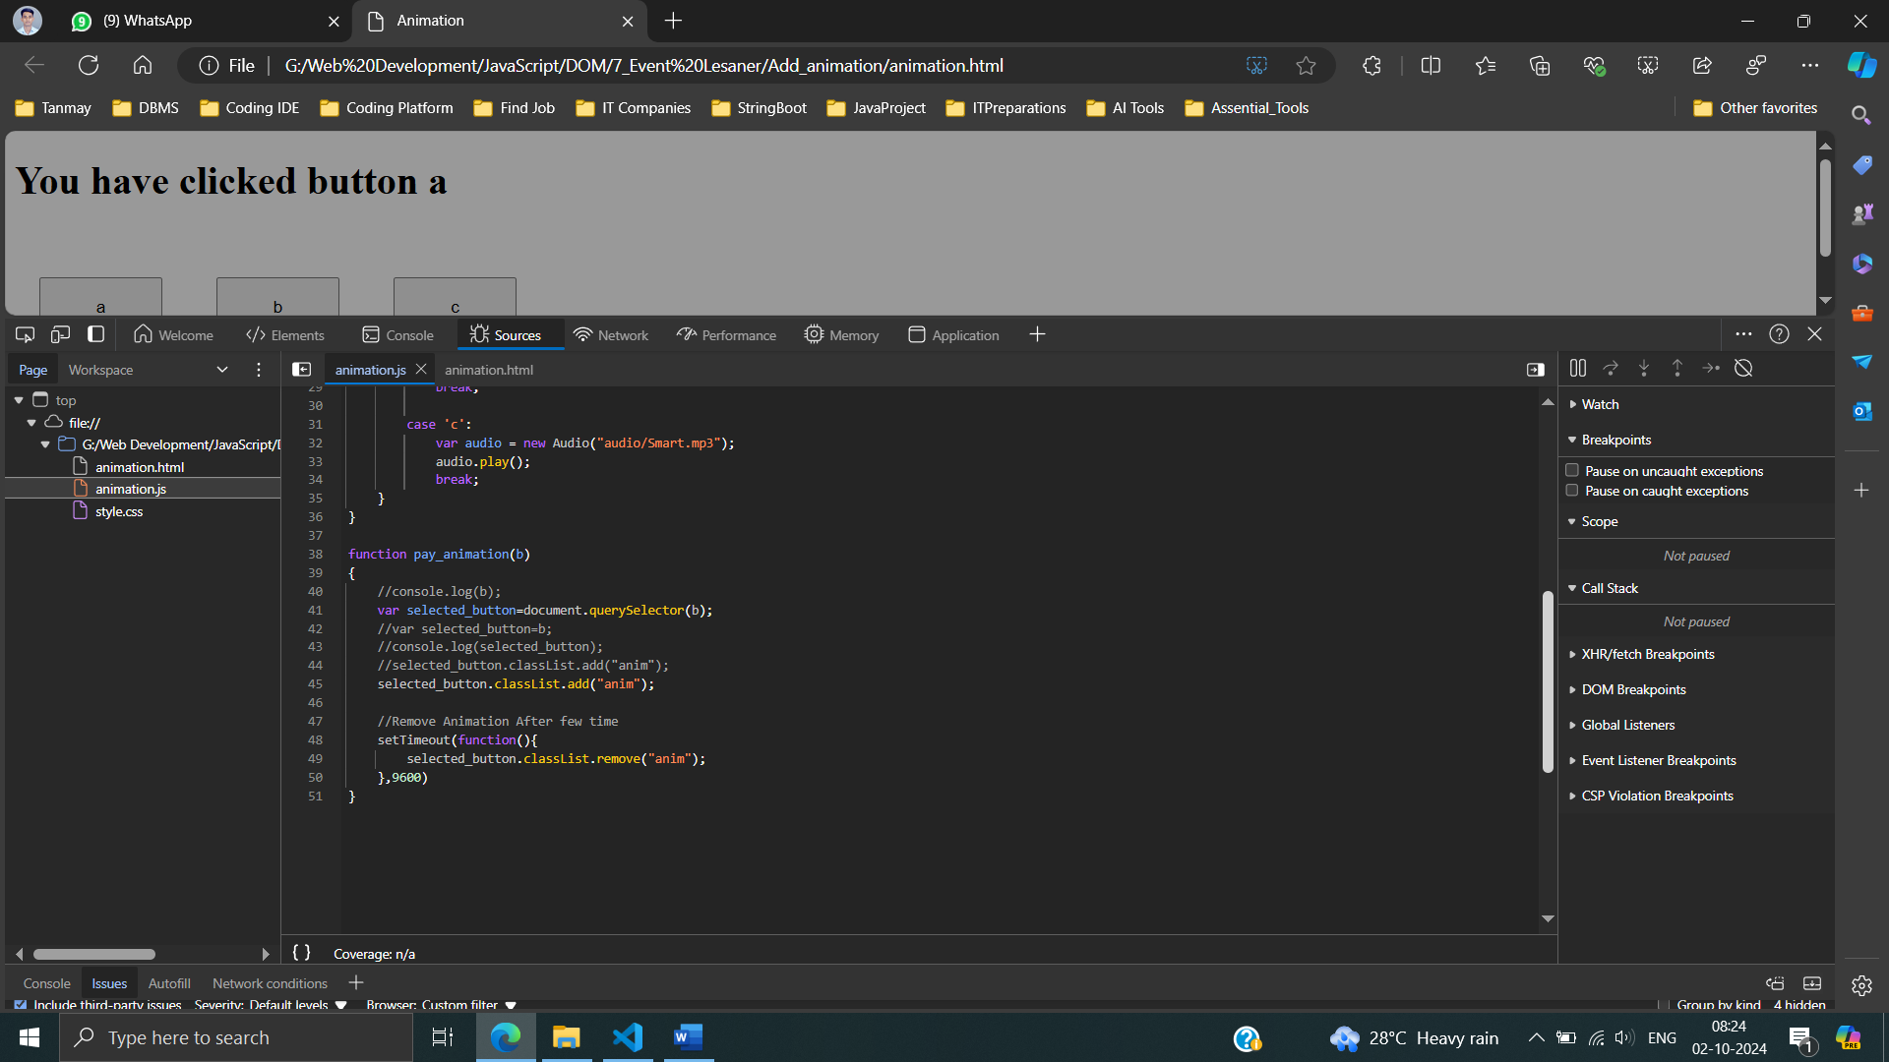

**Keypress Listener :**

keypress events, processes the key information, and triggers corresponding actions (sound and animation) based on the pressed key.



After called click event:



keypressListenerOnButton1.html

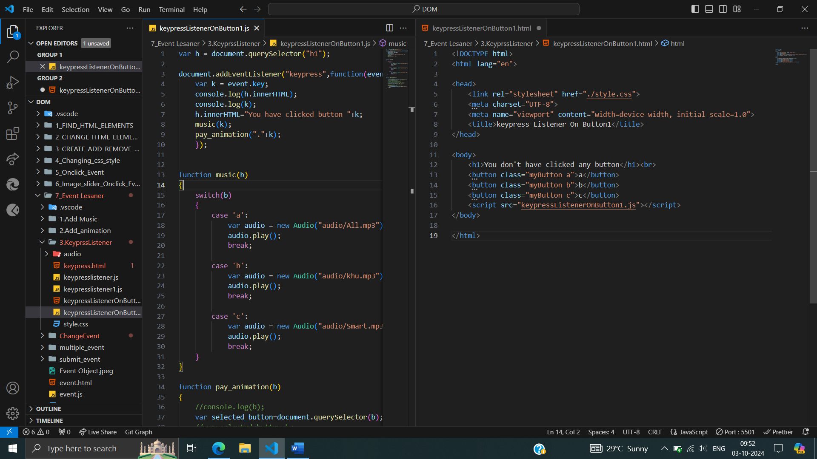

keypressListenerOnButton1.js

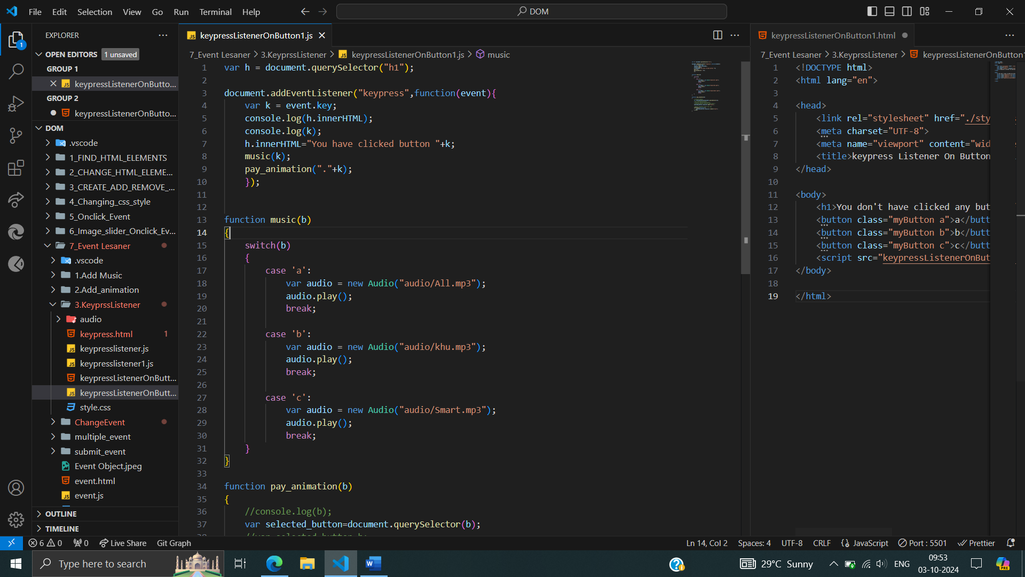

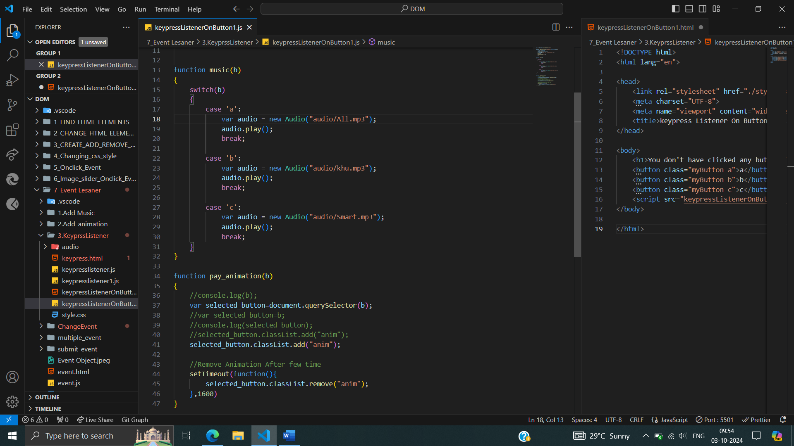

**\* *Dynamically Updating Heading Content Based on Keypresses:***

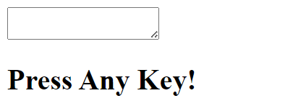

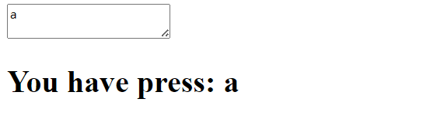

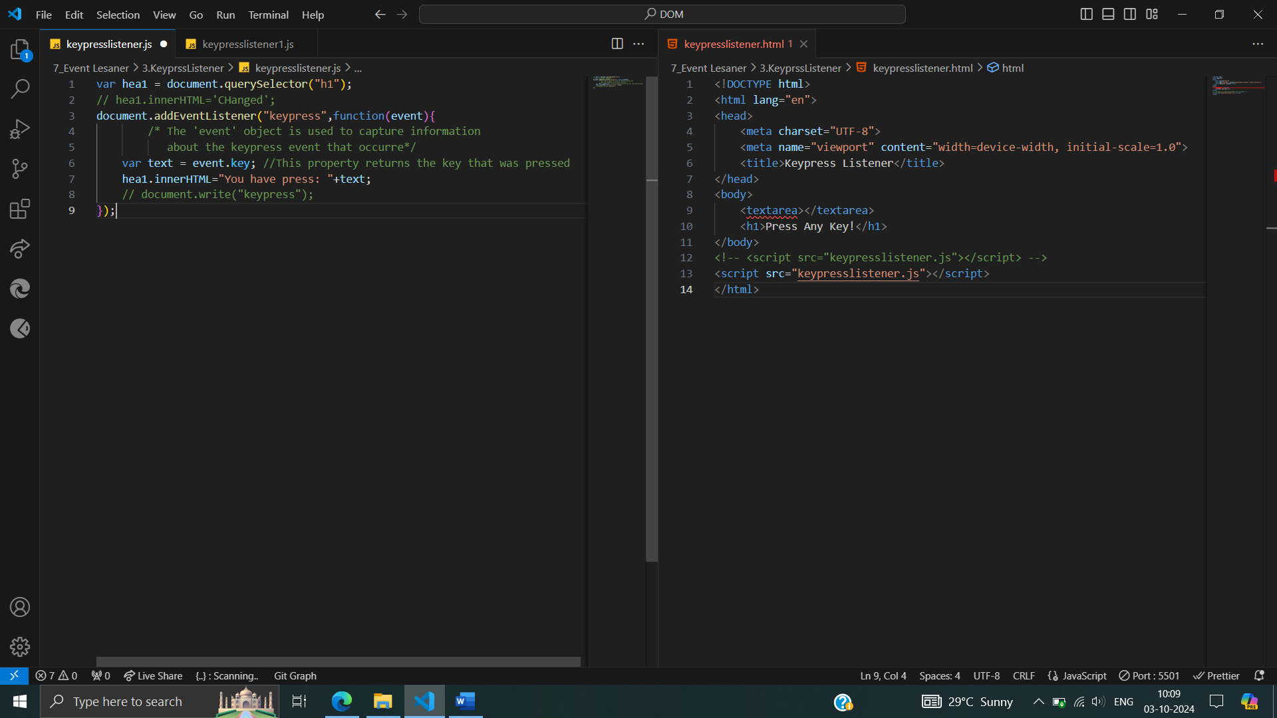



**\*\*Counting No. characters pressed in text area**

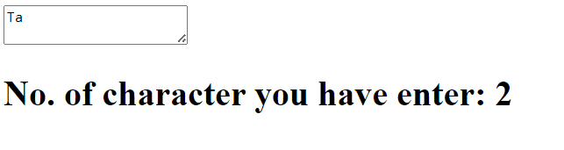

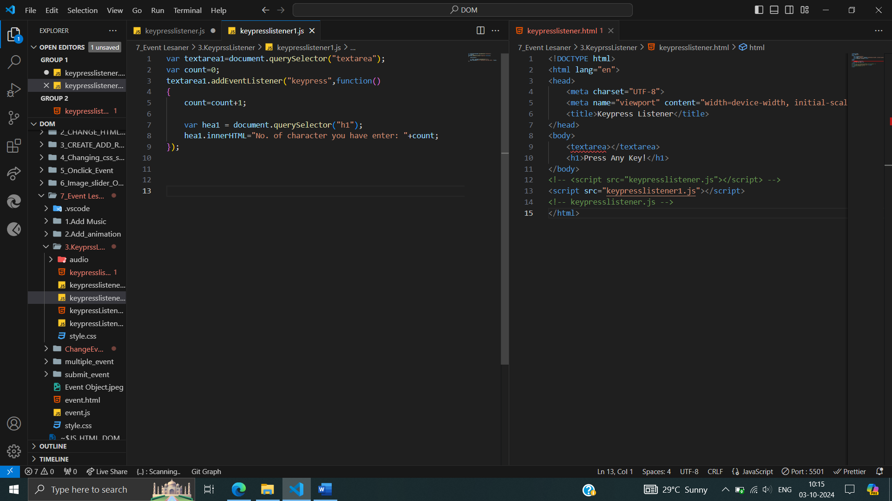

**Change Even Listener :**

The value “Tanmay Samanta” entered into an input field (presumably with a name attribute of "name") whenever the value changes. When the user types in the input field and then either moves focus to a different element or submits the form (depending on browser behavior), the changeHandler function logs the updated value to the console.

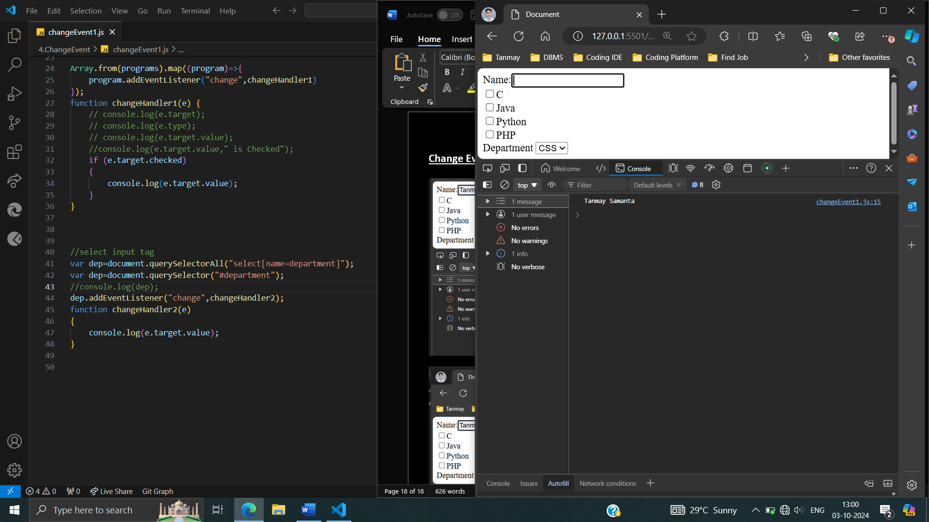 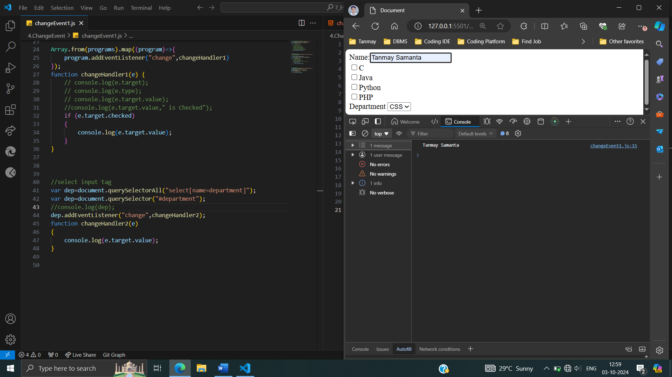

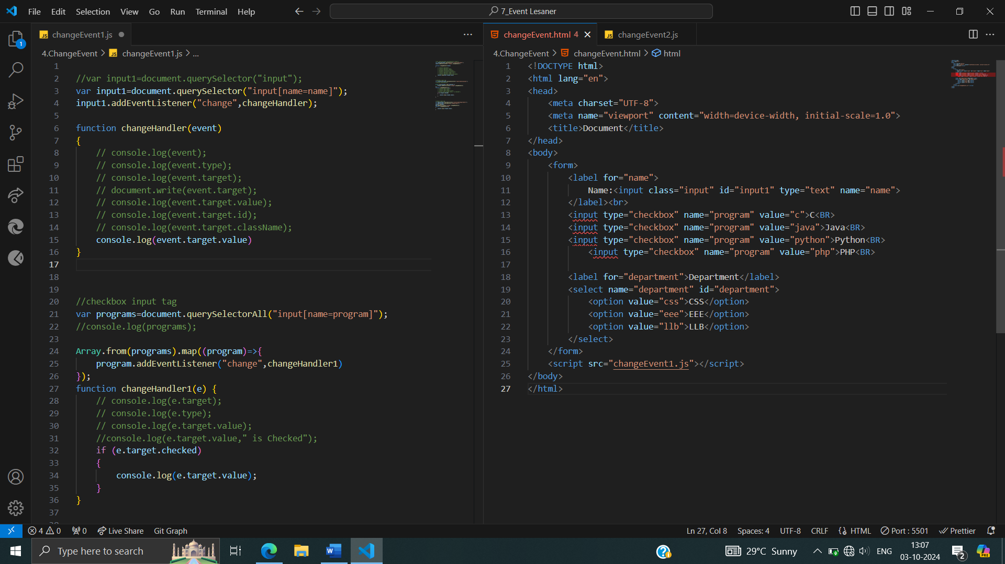

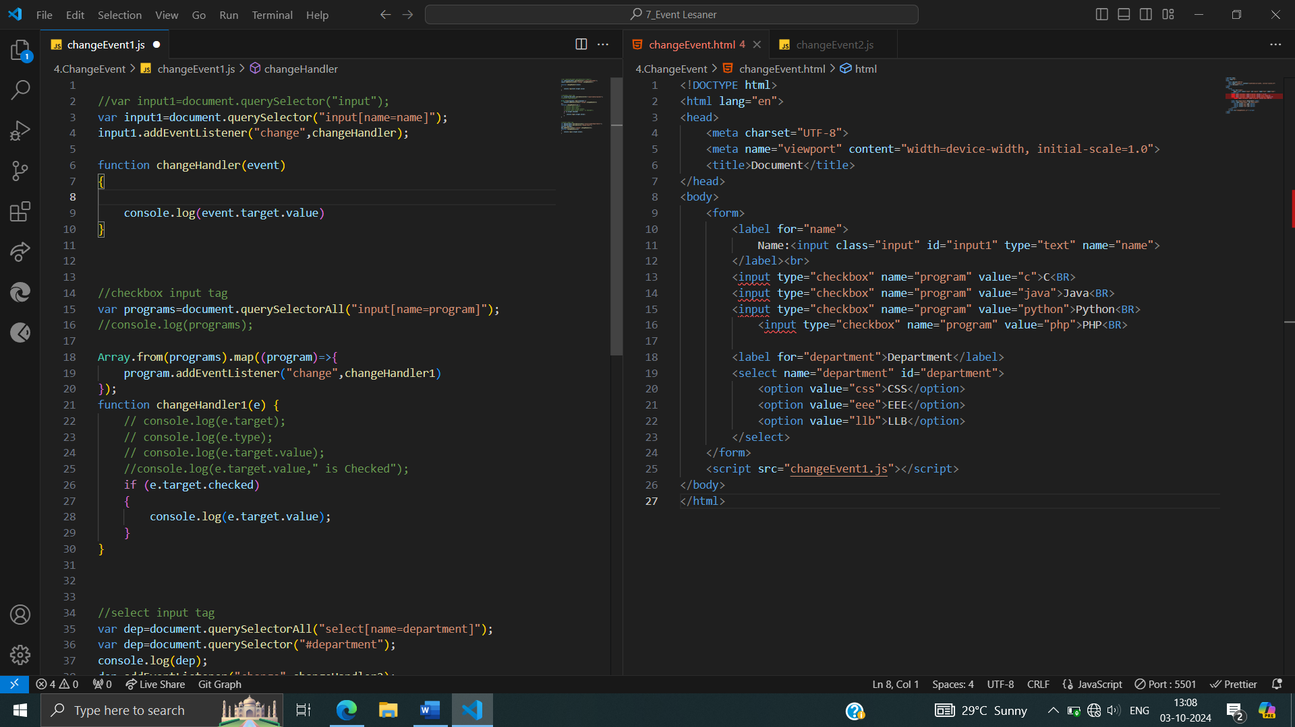

**Event Listeners for Checkboxes:**

Dynamic Checkbox Handling or Capturing Checkbox Changes.

Listens for checkbox changes and logs their values when checked, providing a mechanism to track user selections.

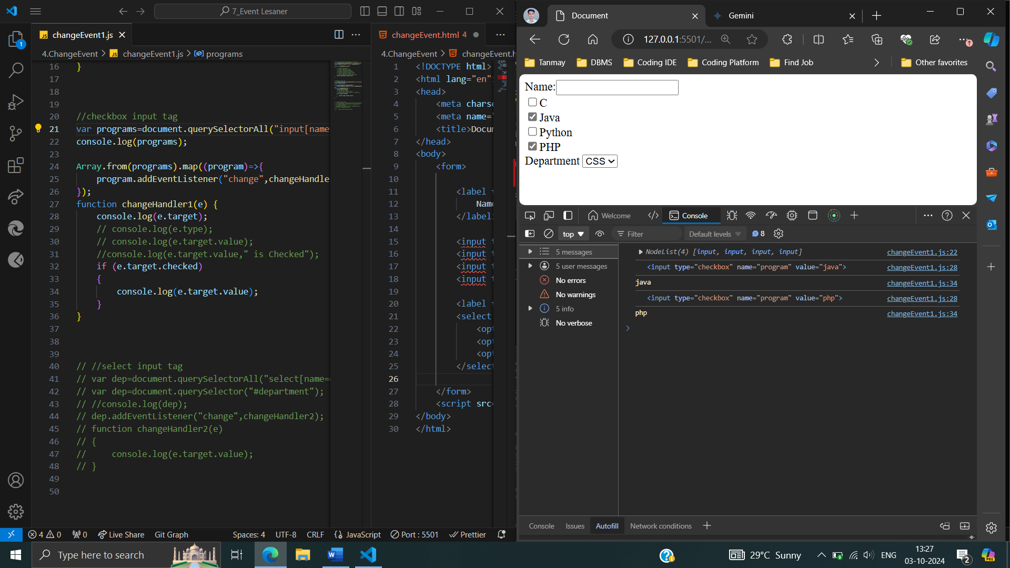

 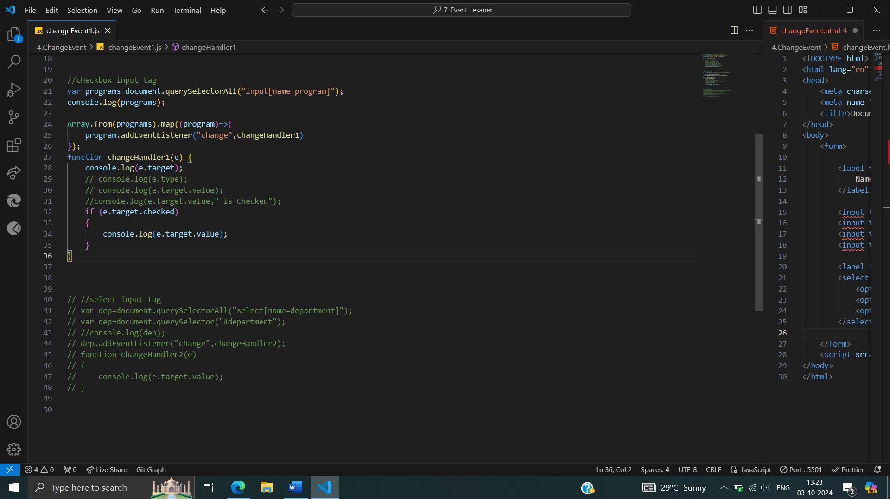

*\*\*****Dynamic Department Selection*** *or* ***Capturing Department Changes in Dropdown***

Captures user interaction with a select input element (dropdown list). When a different option is selected, the changeHandler2 function executes, logging the selected option's value to the console. You can modify changeHandler2 to perform more complex actions based on the user's choice, such as updating other elements, performing calculations, or submitting data to a server.

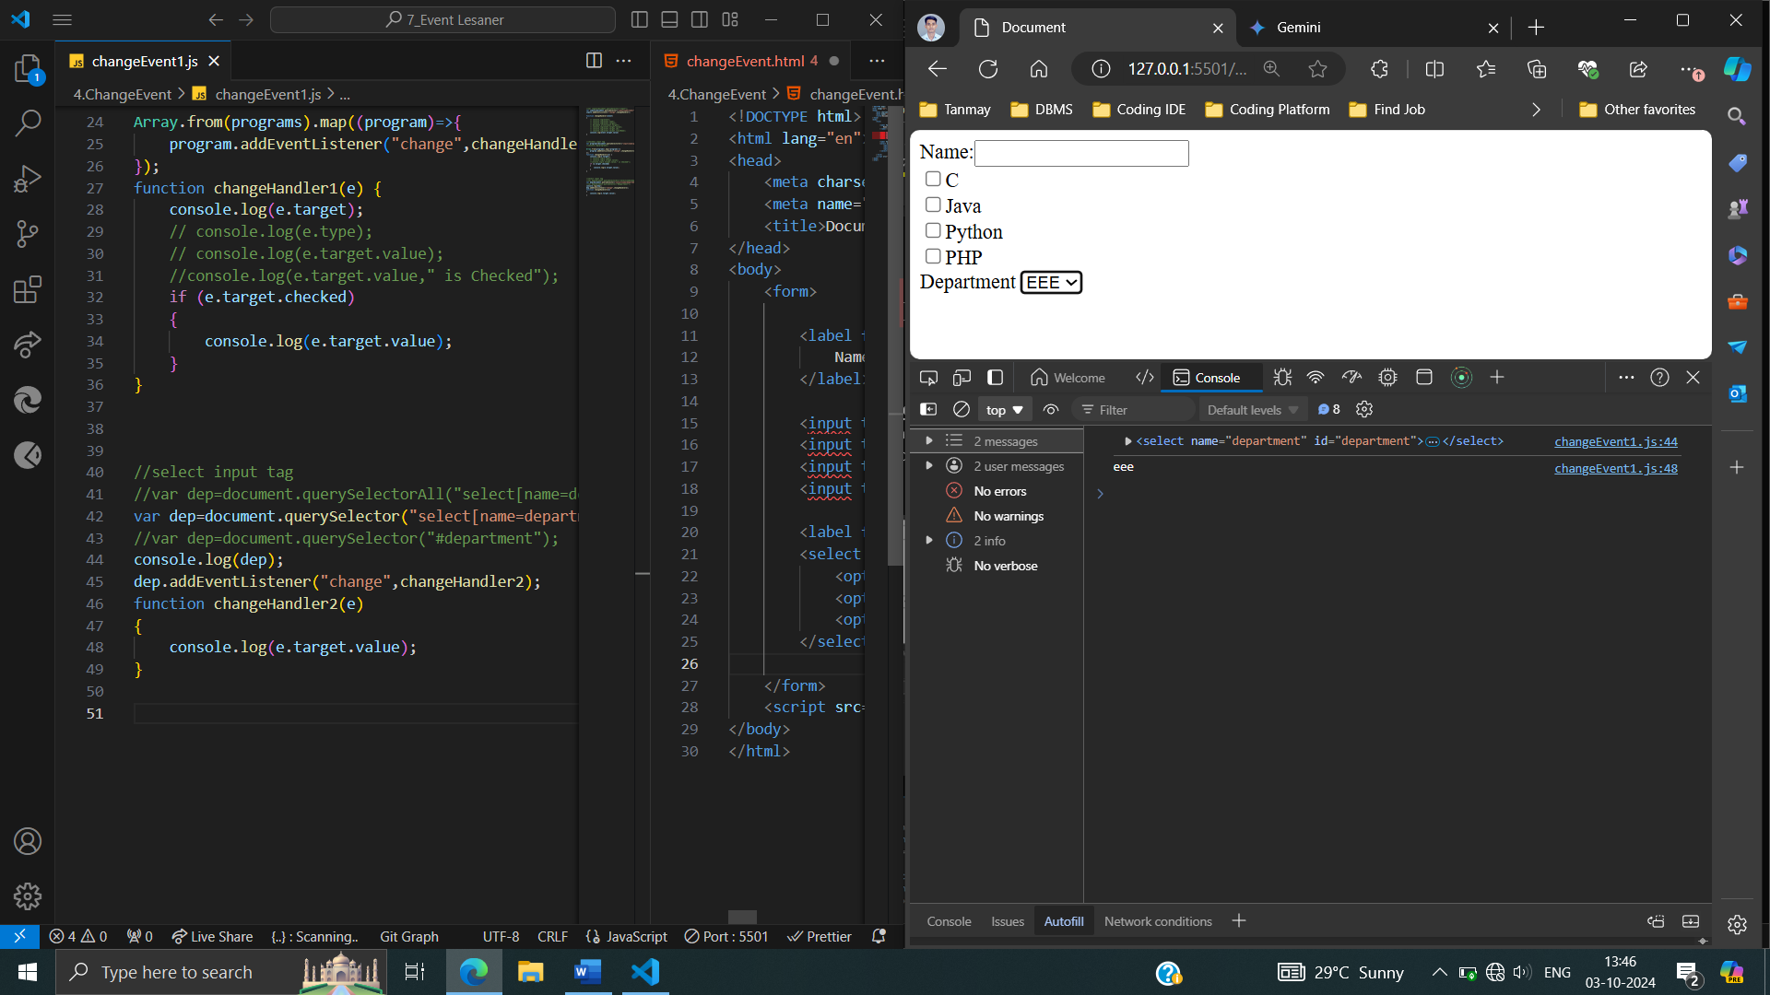



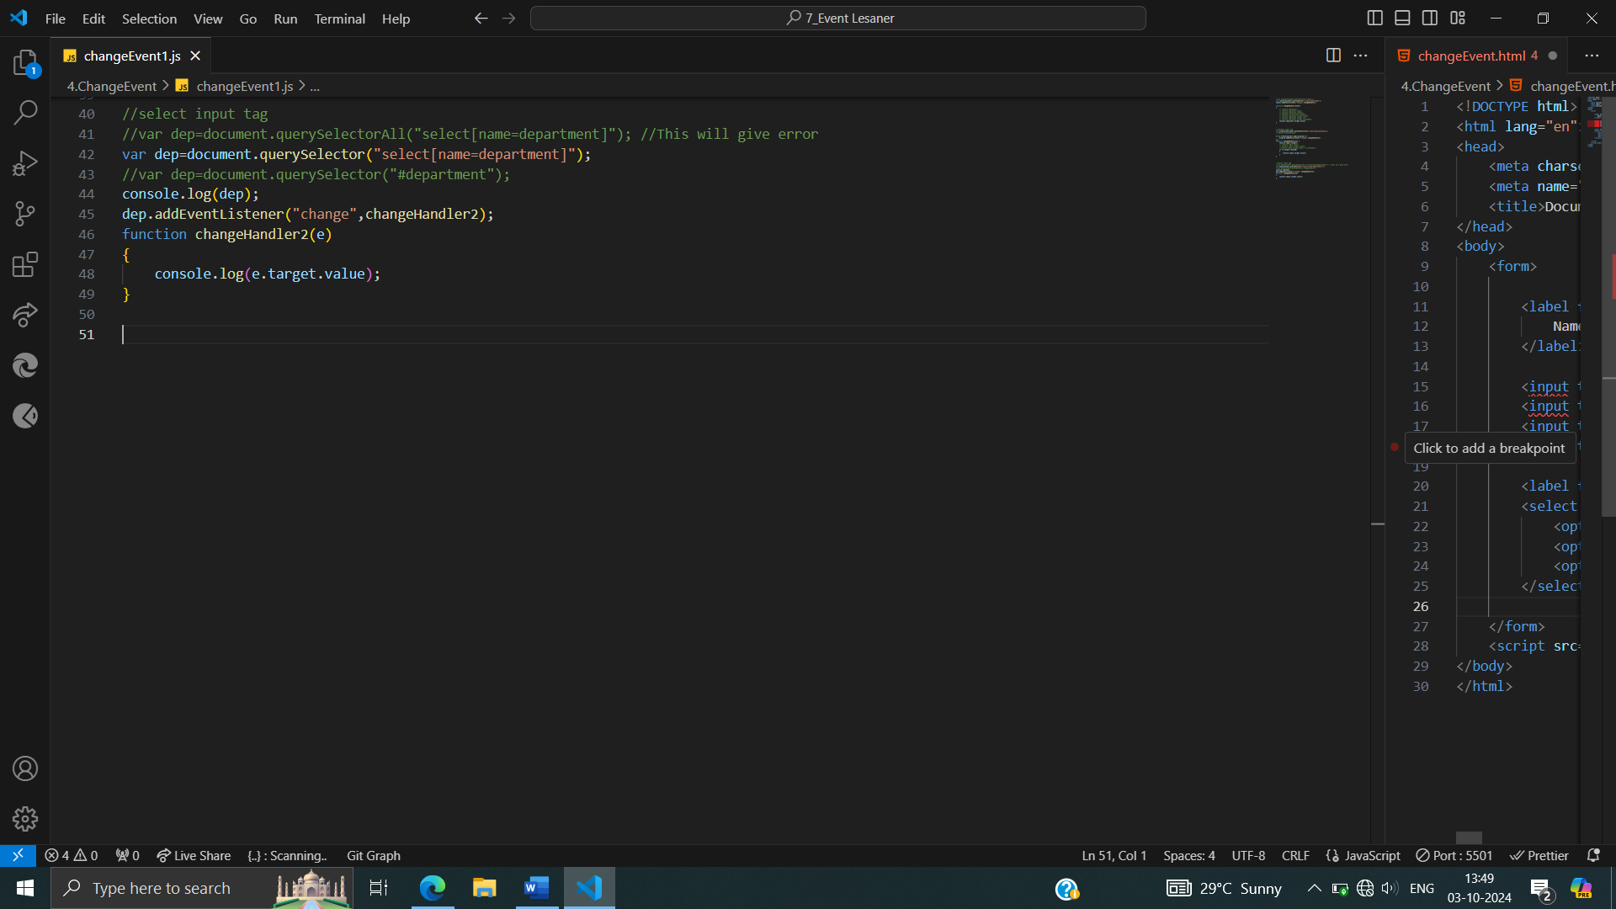

**Submit Even Listener :**

**Submit Event Listener** allows you to intercept and handle form submission events.

When a user submits a form (by clicking a submit button or pressing Enter), the listener is triggered.

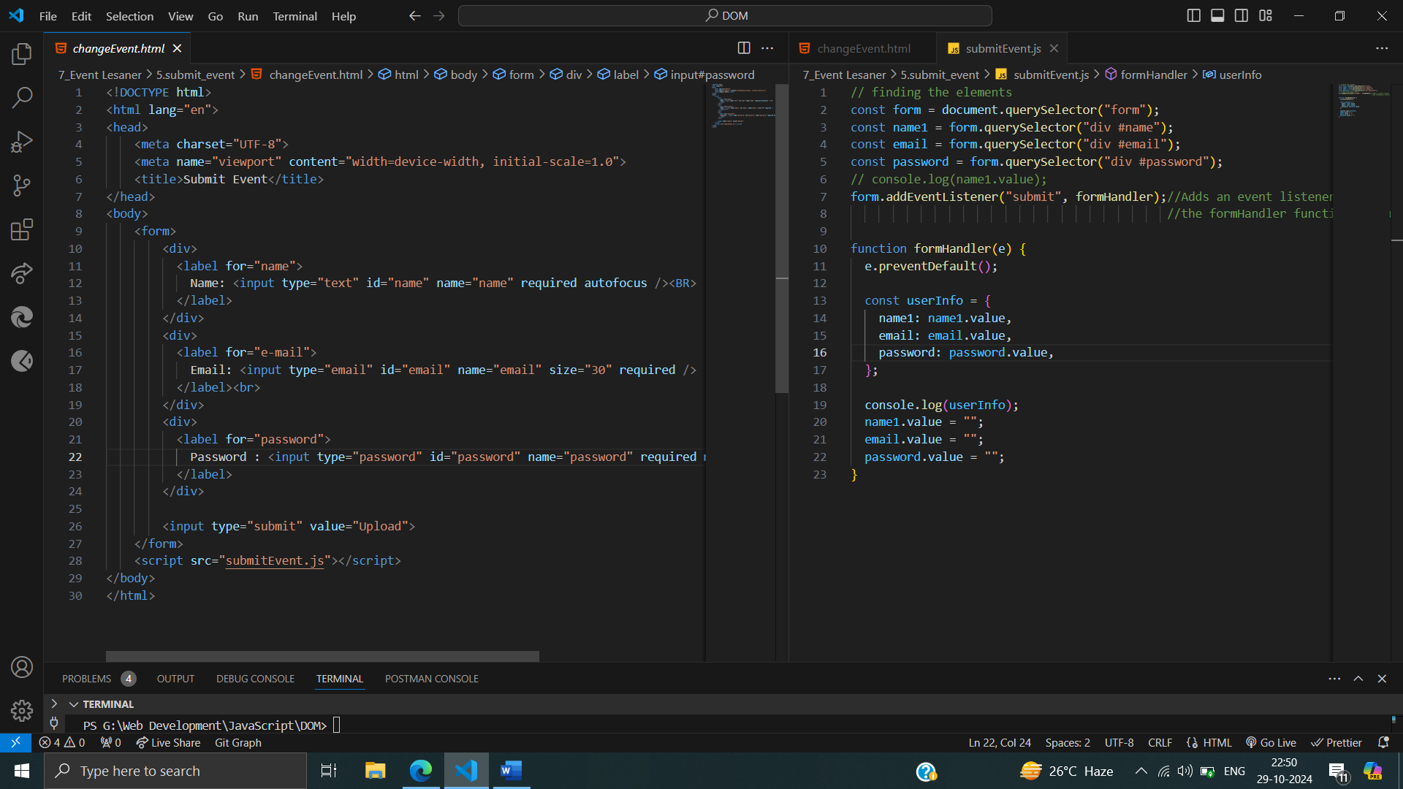



How to add an event listener to a form element to capture form submission events. When the form is submitted, the specified function (formHandler) is executed, allowing for further processing of the form data.

**Media Event Listener :**

Media is triggered when a media element (like an audio or video player) reaches a specific state or point in its playback. These events allow you to respond to changes in the media's playback state, such as when it starts playing, pauses, ends, or when the current playback time changes.

By using media events, you can create interactive and dynamic media experiences on web pages.

and

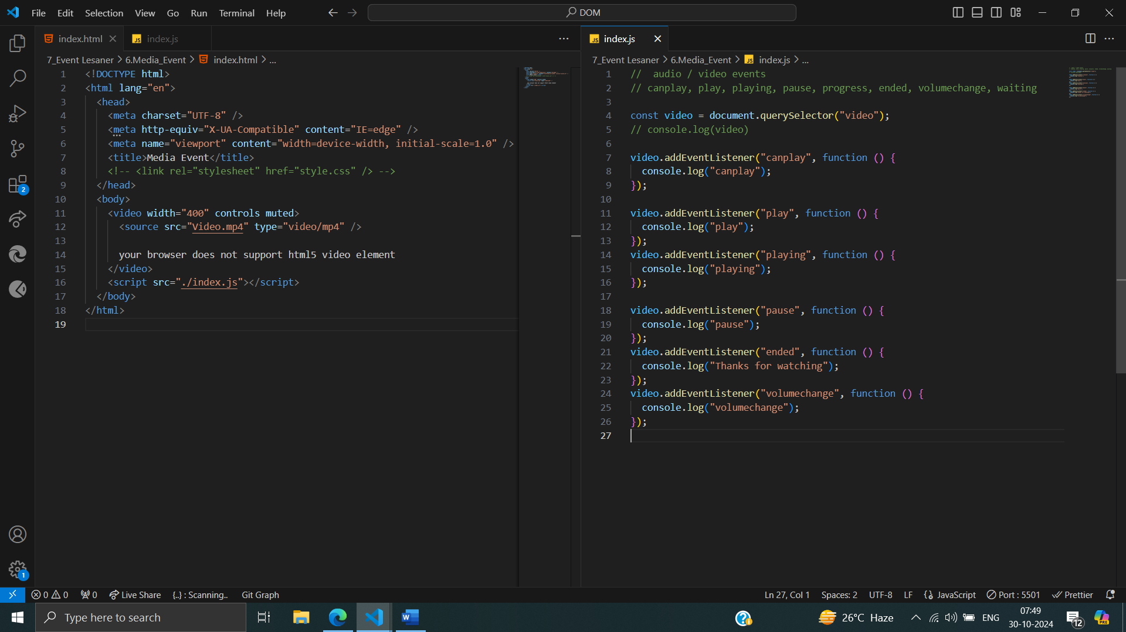



**More-event-object Listener :**

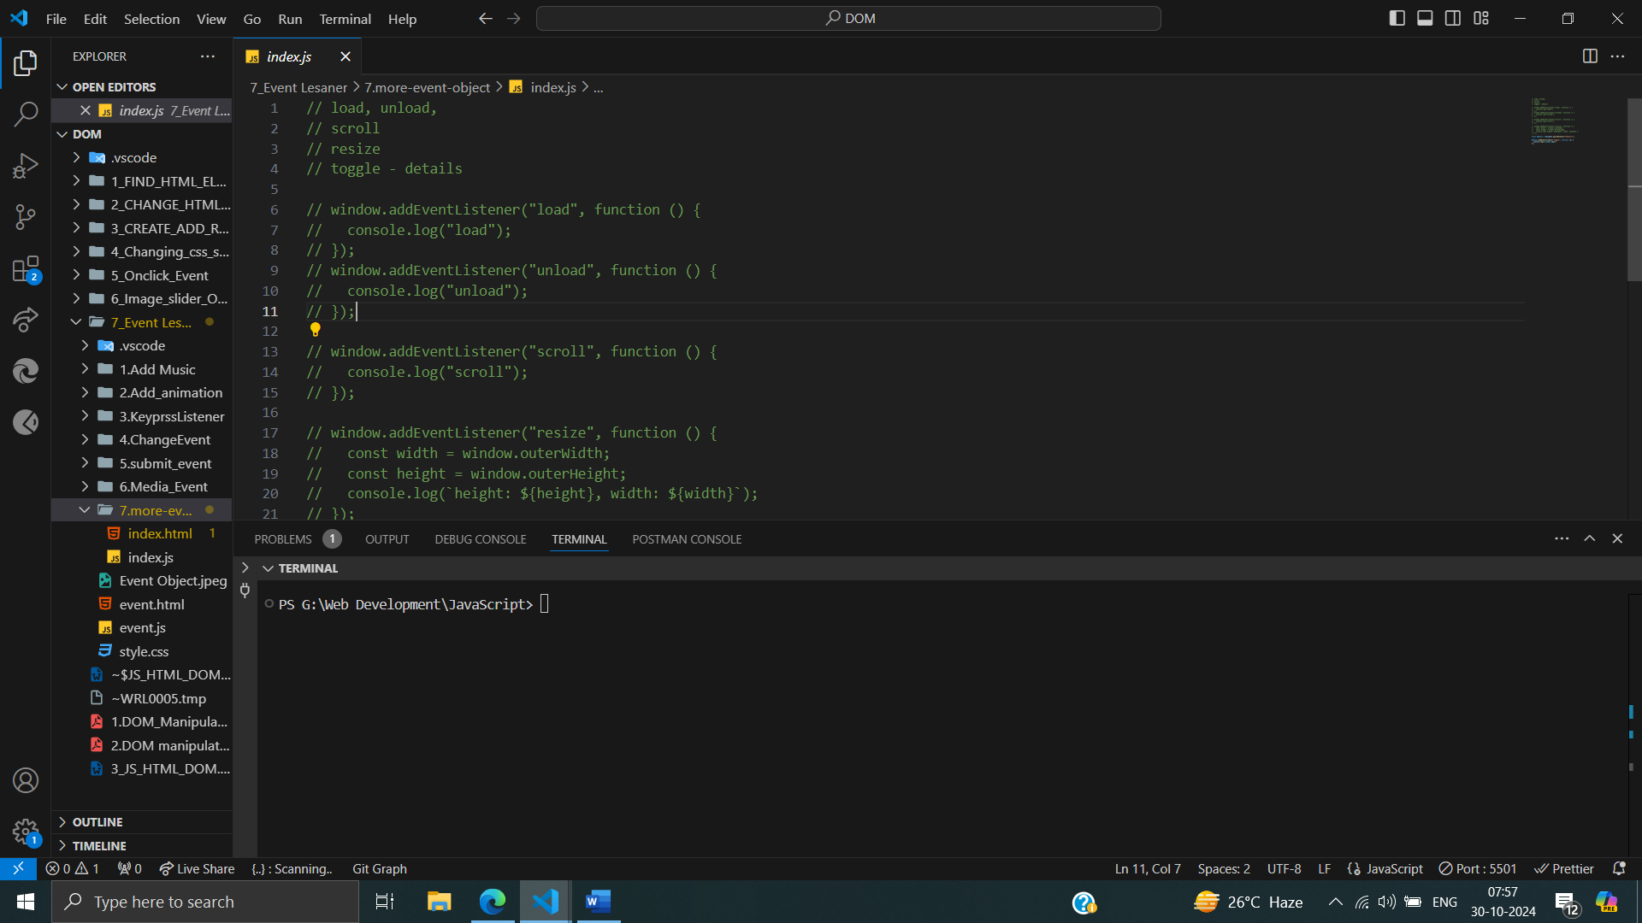

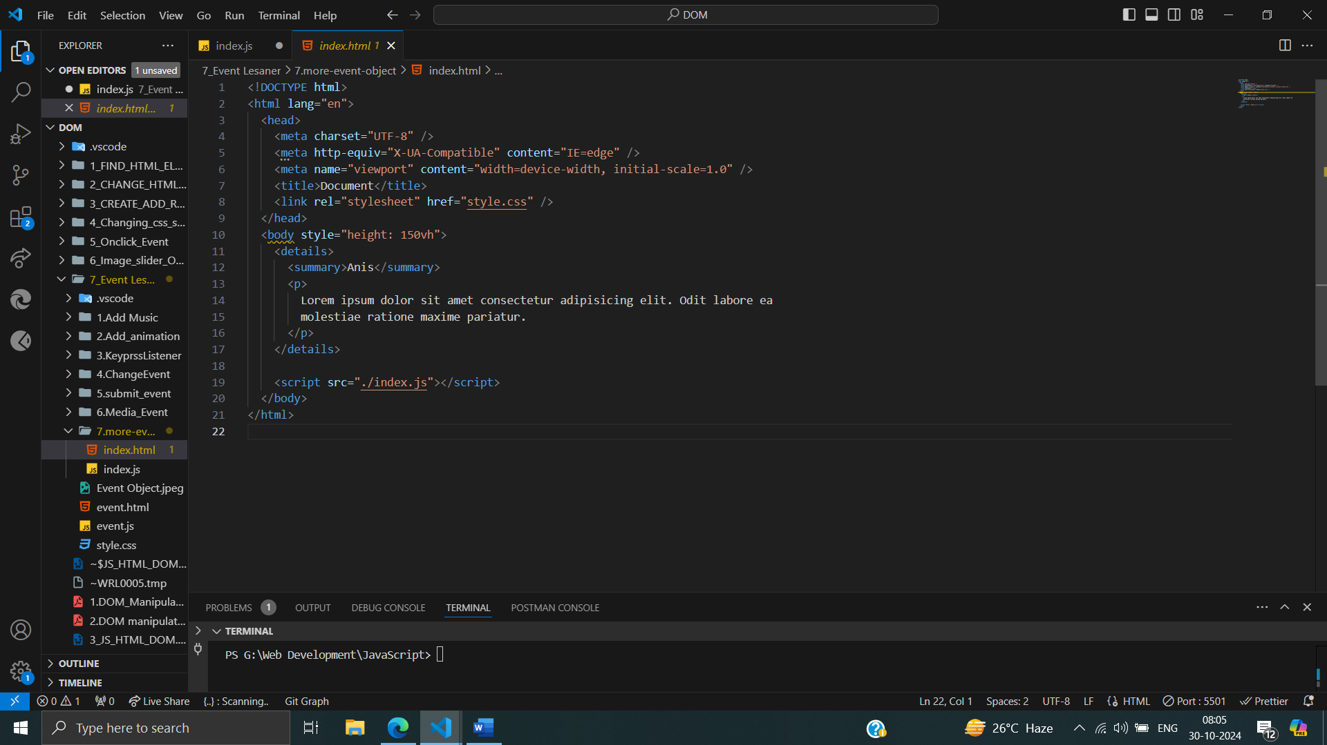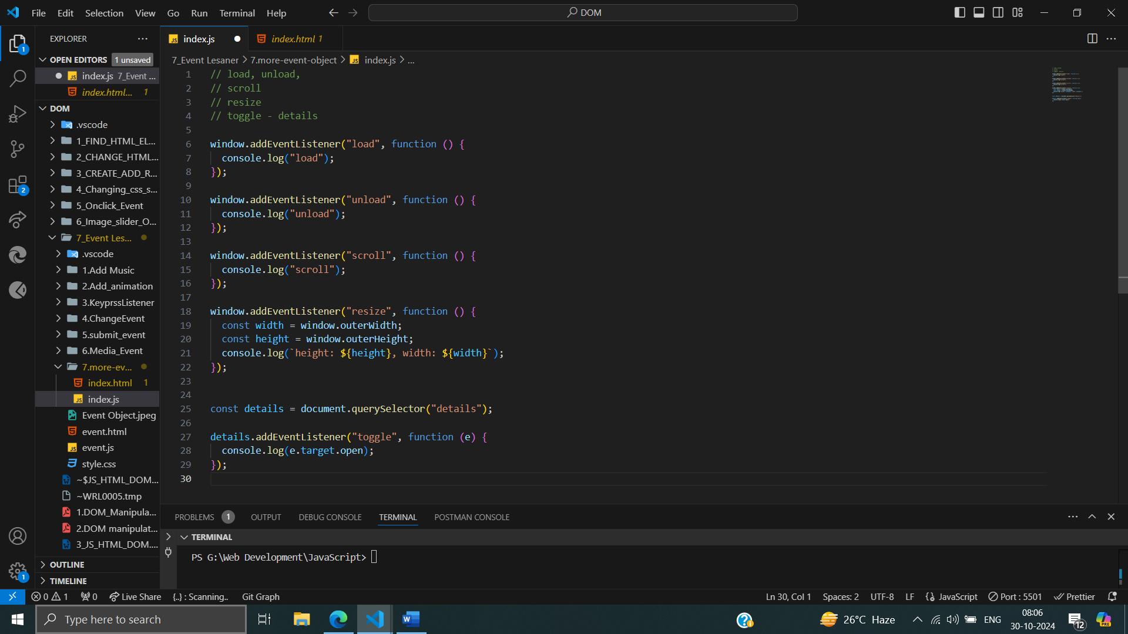

Adds event listeners to the window object to capture various events.

These event listeners allow you to perform actions or trigger functions based on these specific events.

• **Load Event:**

* Triggers when the page has fully loaded.
* Logs "load" to the console.

• **Unload Event:**

* Triggers when the page is about to unload or close.
* Logs "unload" to the console.

• **Scroll Event:**

* Triggers whenever the user scrolls the page.
* Logs "scroll" to the console.

• **Resize Event:**

* Triggers when the browser window is resized.
* Logs the current window height and width to the console.

• **"details.addEventListener('toggle', ...)"**: This part focuses on a specific HTML element, the <details> tag. It adds an event listener to the details element, specifically for the "toggle" event. The "toggle" event fires whenever the user opens or closes the details summary. The function logs e.target.open to the console, which indicates whether the details are currently open (true) or closed (false).

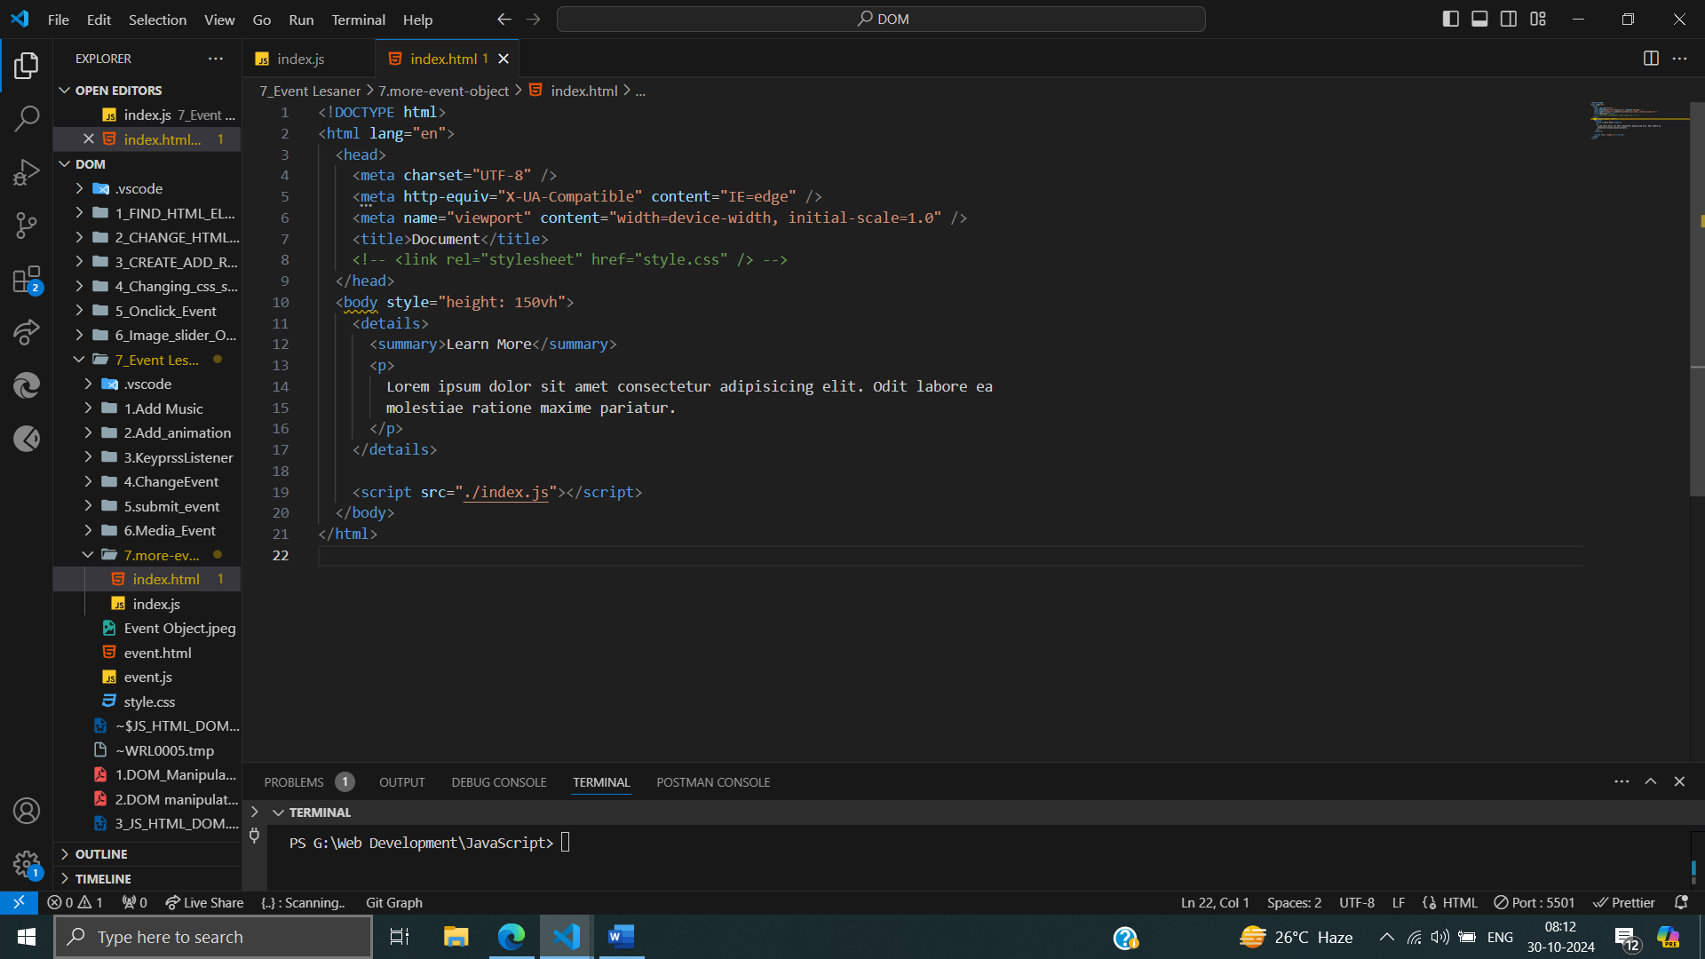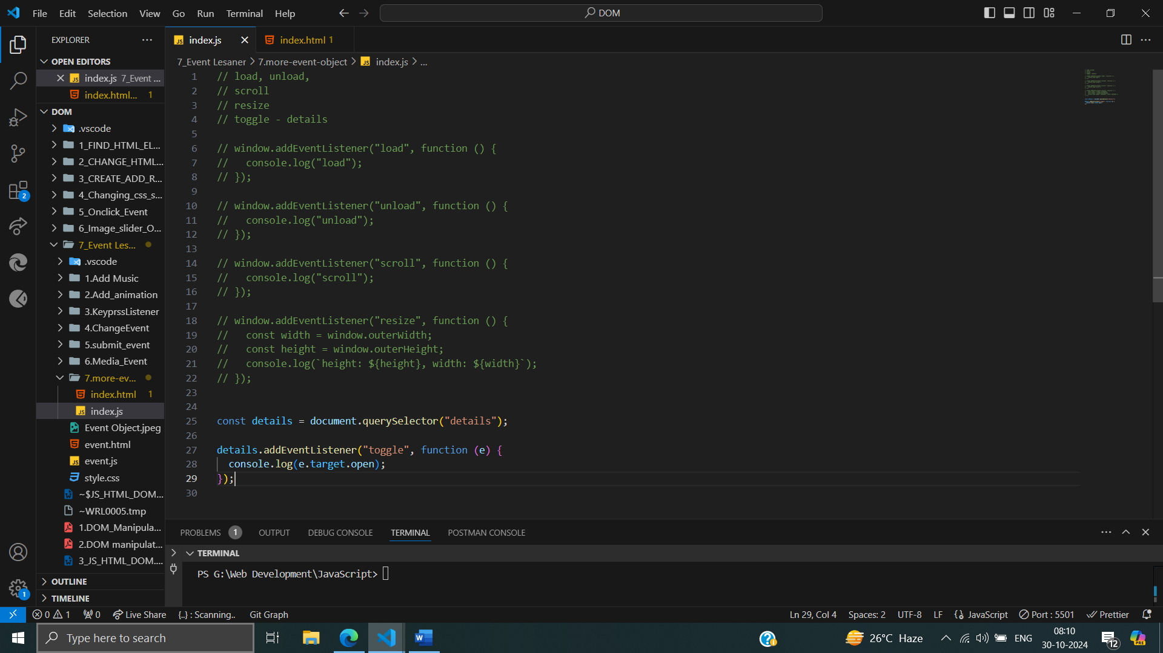

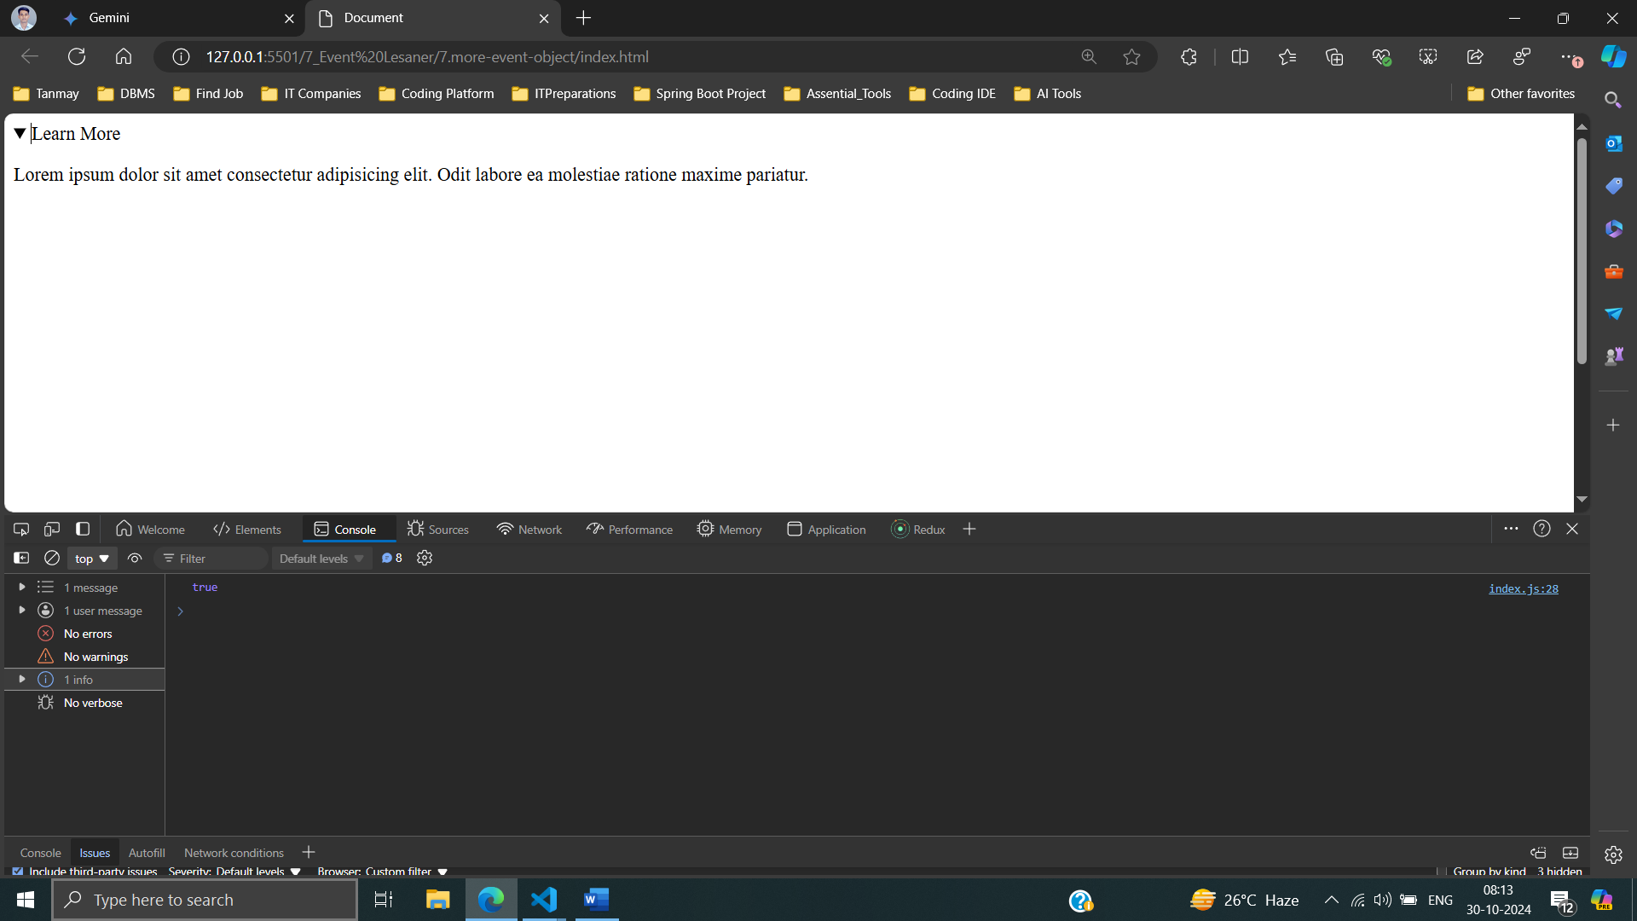

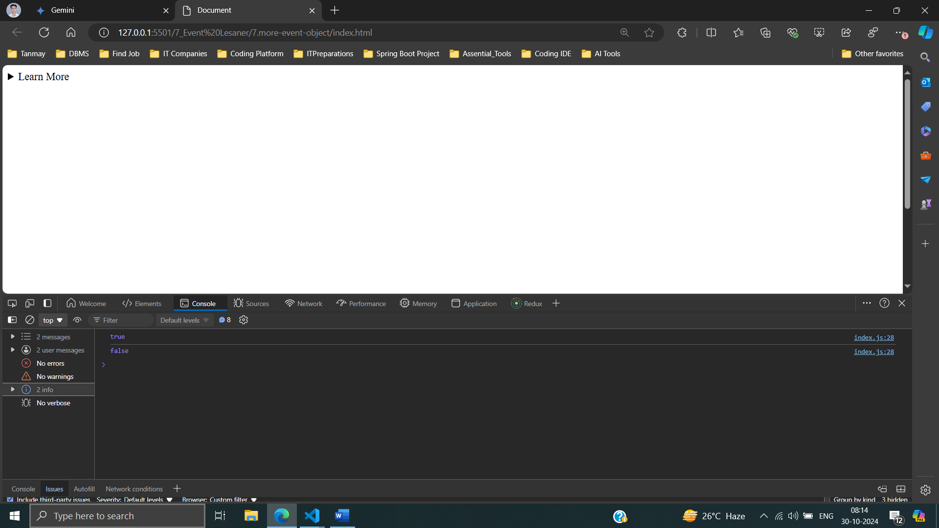

**Mouse-events :**

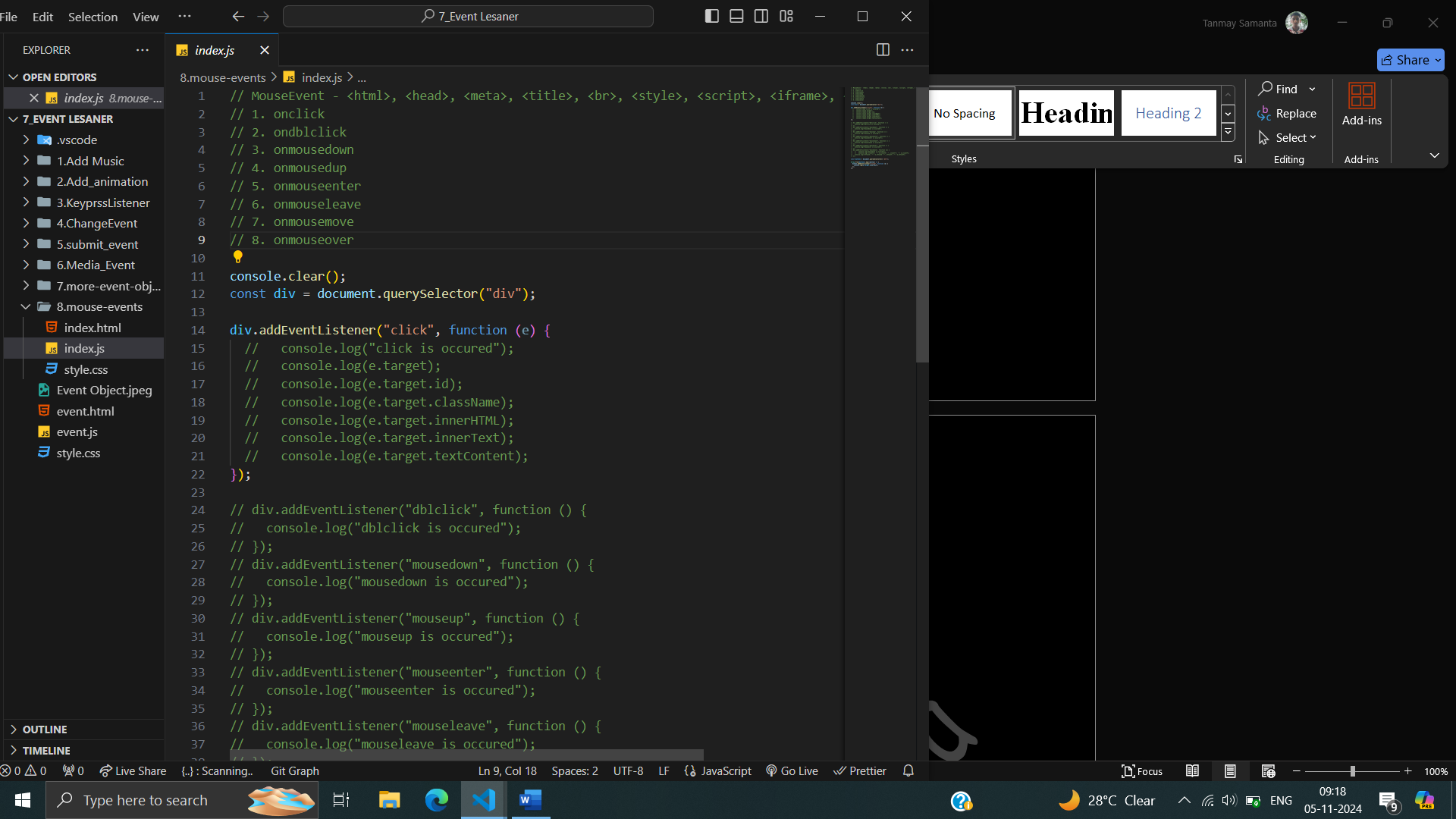

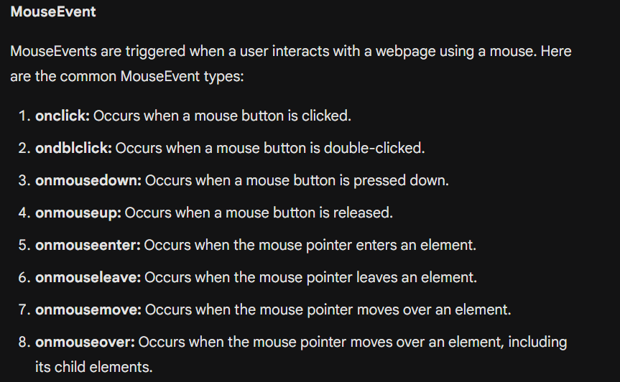

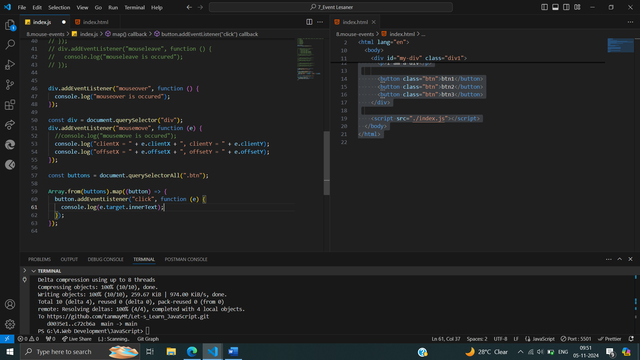

mousemove event listener to a div element. When the mouse moves over the div, the event handler function is triggered.

Inside the event handler, the following information is logged to the console:

1. **clientX and clientY:** These properties provide the x and y coordinates of the mouse pointer relative to the viewport (the visible area of the browser window).
2. **offsetX and offsetY:** These properties provide the x and y coordinates of the mouse pointer relative to the top-left corner of the element that triggered the event (in this case, the div).

**KeyboardEvent:**

A KeyboardEvent is a type of event that is triggered when a user interacts with a webpage using a keyboard. It provides information about the key that was pressed, such as the key code, character code, and whether the key was pressed or released.

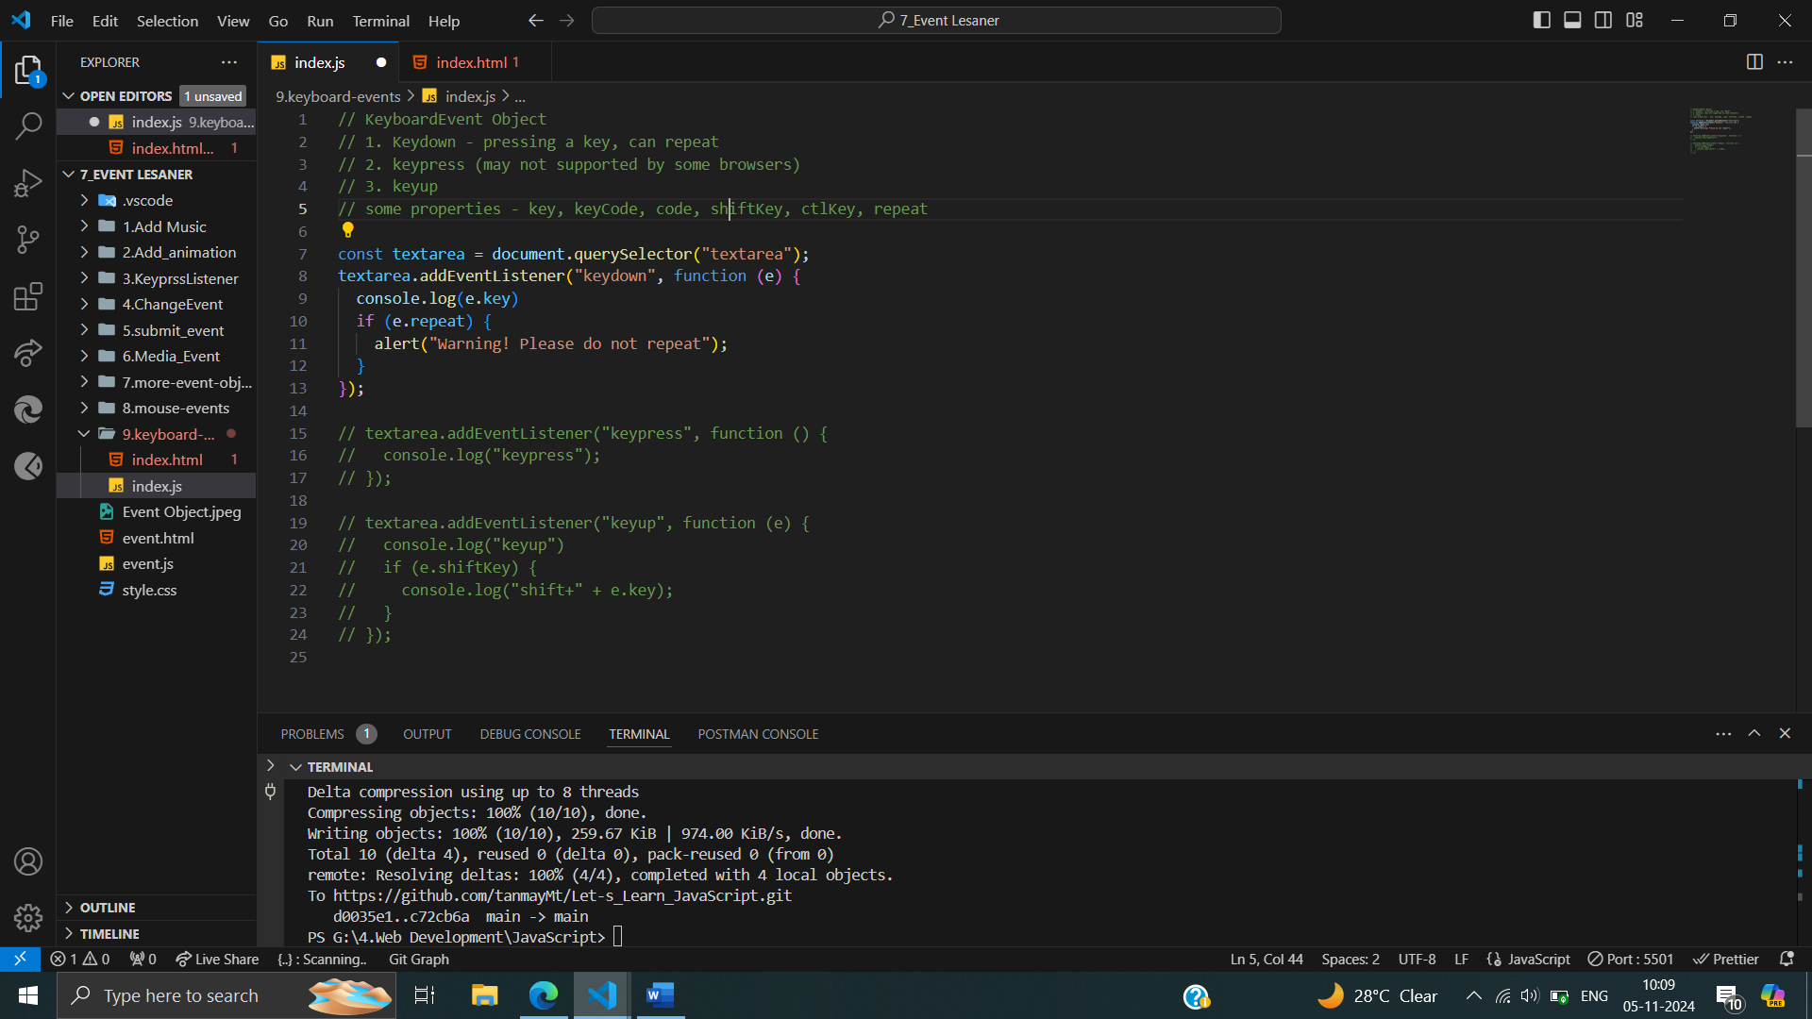

1. **keydown:** Occurs when a key is pressed down. It can repeat if the key is held down.
2. **keypress:** Occurs when a key is pressed and released. This event may not be supported by all browsers.
3. **keyup:** Occurs when a key is released.